**LAB 1**

**1) Print current month calender.**

**CODE:-**

ncal

**Output:**

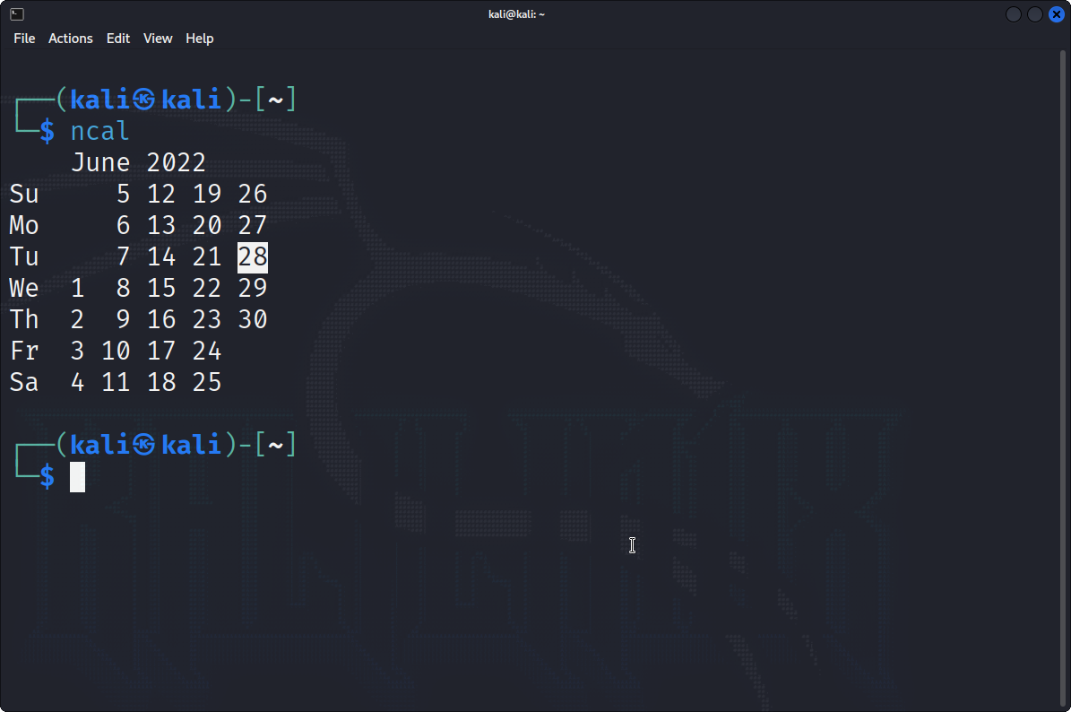

**2) Print calender of May, June and July of previous year.**

**CODE:-**

ncal -3 –m apr –m may –m jun 2021

**Output:**

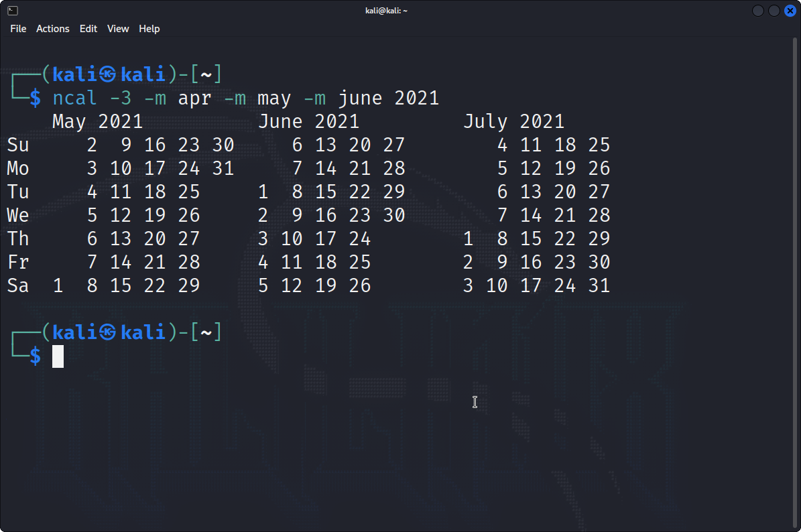

**3) Convert decimal number to hexadecimal.**

**CODE:-**

bc

obase = 16

7452145984

1BC2EB814

**Output:**

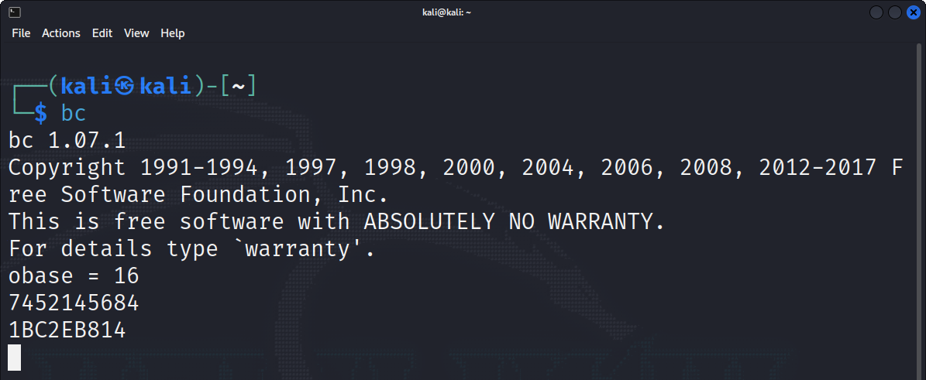

**4) Display following message by applying one command.**

**Hello Everyone.**

**Today’s date is: (Example: 12 jul 2021)**

**CODE:-**

Echo Hello Everyone. ; echo “Today’s date is:” `date +’%d %b %y’`

**Output:**

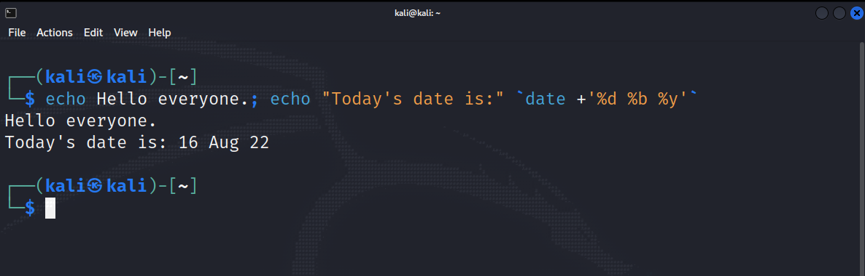

**5) Display following message by applying one command.**

**Hello Everyone.**

**Today is <Print weekday name in long> (Example: Today is Sunday).**

**CODE:-**

echo Hello Everyone. ; echo “Today is” `date +%A`

**Output:**

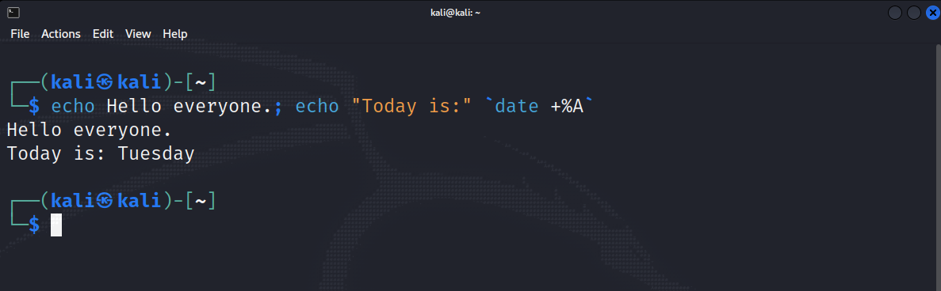

**6) Check your current directory.**

**CODE:-**

pwd

**Output:**

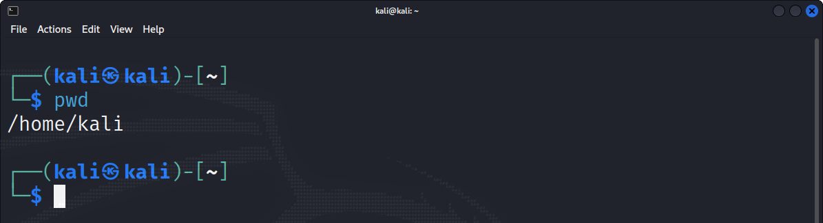

**7) Create a folder “UNIX”, “ASP” and “PHP” in “v:** **\” drive.**

**CODE:-**

mkdir UNIX ASP PHP

**Output:**

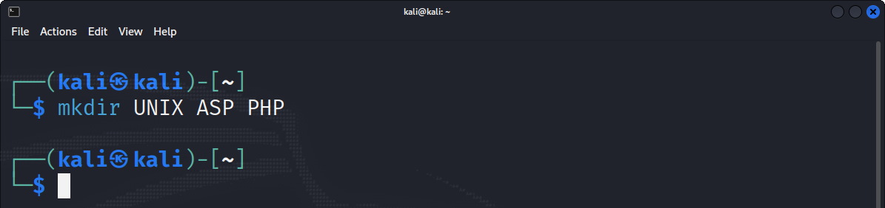

**8) Move to directory “UNIX”.**

**CODE:-**

cd UNIX

**Output:**

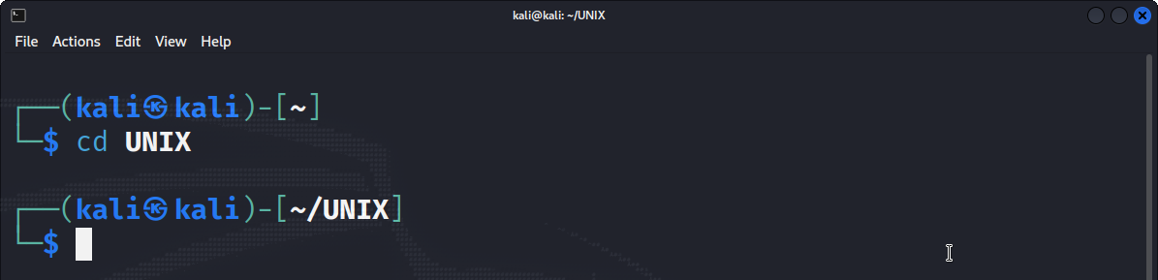

**9) Create two more directories “Assignment” and “Test” in “UNIX” directories.**

**CODE:-**

mkdir Assignment Test

**Output:**

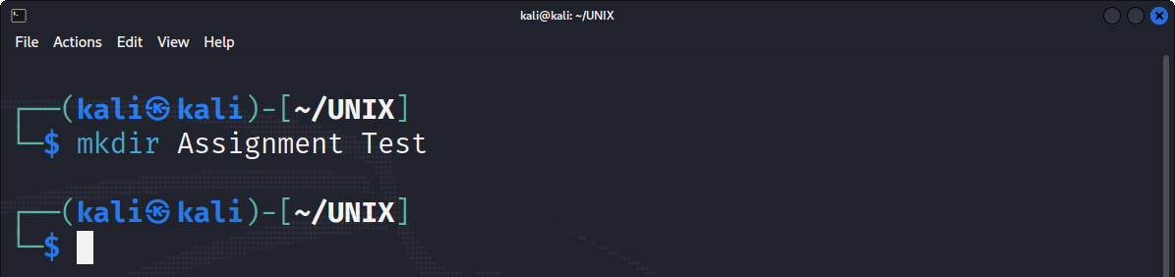

**10) Move to directory “PHP” with only one command.**

**CODE:-**

cd ../PHP

**Output:**

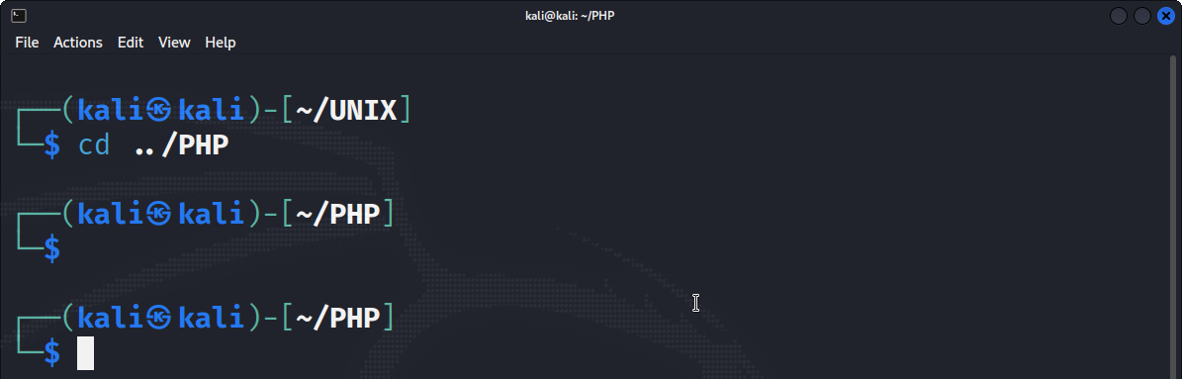

**11) Create a folder “UNIX”, “ASP” and “PHP” in “v:** **\” drive.**

**CODE:-**

mkdir UNIX ASP PHP

**Output:**

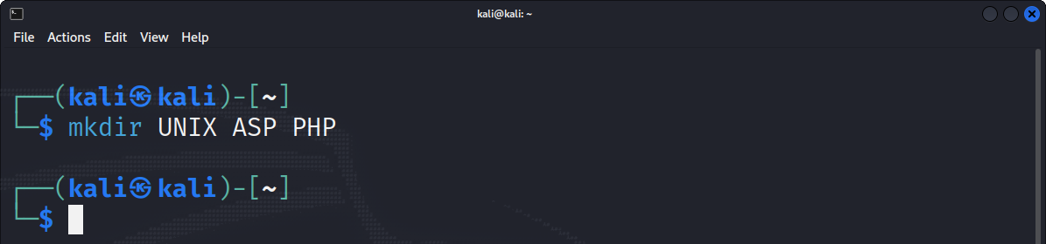

**12) Create directory “Web” under “ASP” directory without moving from the “PHP” directory.**

**CODE:-**

mkdir ../ASP/Web

**Output:**

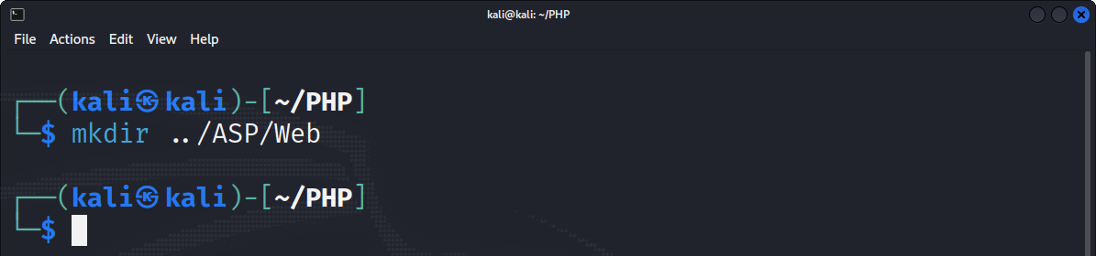

**13) Create directory “Project”, “Temp” and “Exam” under “Web” directory which resides in “ASP” without moving from “PHP” directory.**

**CODE:-**

mkdir ../ASP/Web/Project ../ASP/Web/Temp ../ASP/Web/Exam

**Output:**

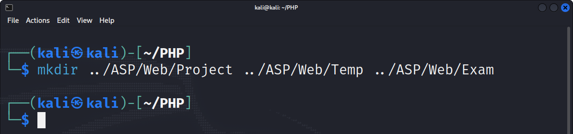

**14) Create empty files “test1”, “test2” and “test3” using one command in current directories.**

**CODE:-**

touch test1 test2 test3

**Output:**

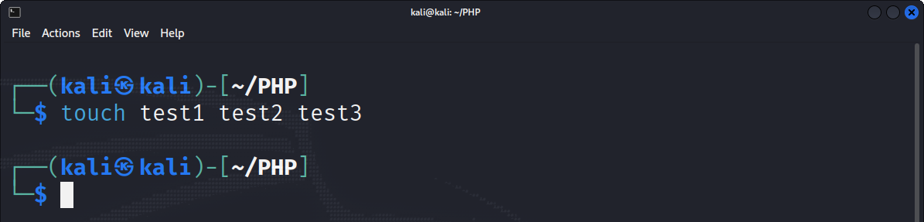

**15) Display previous working directory.**

**CODE:-**

cd .. ; ls

**Output:**

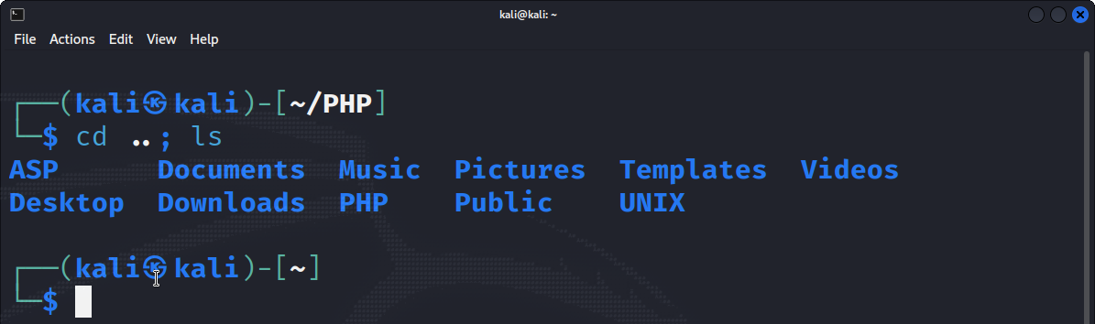

**16) Write three different ways to move to home directory.**

**CODE:-**

* cd
* cd ~
* cd $HOME

**Output:**

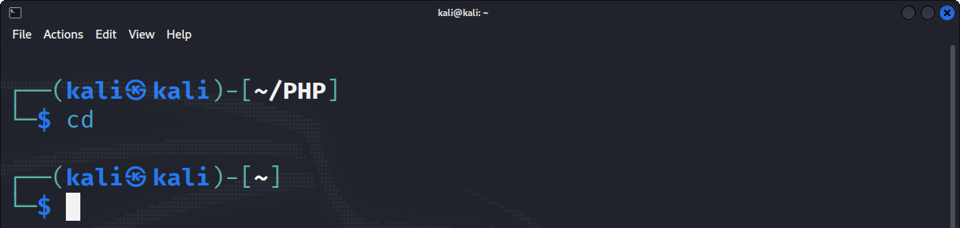

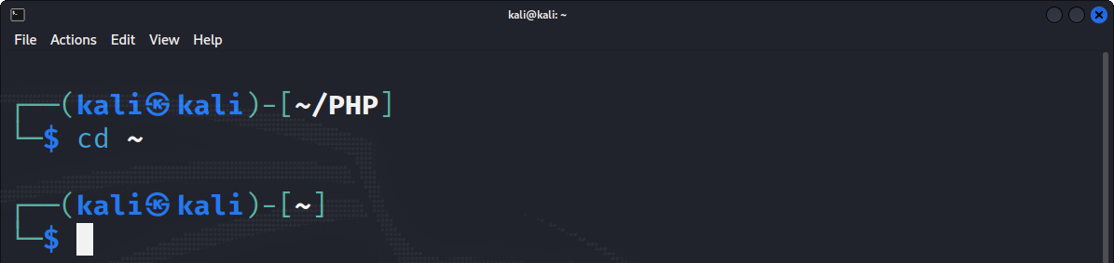

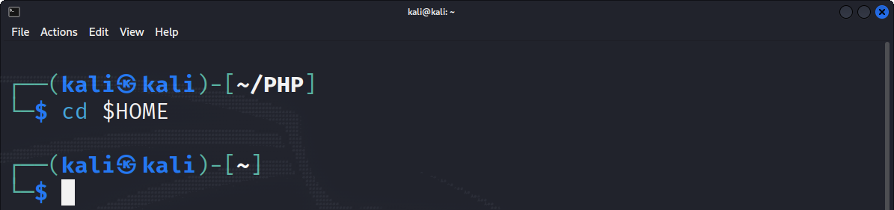

**LAB 2**

**1) Delete directory “ASP” with all it’s sub directory using single command.**

**CODE:-**

rm –r ASP

**Output:**

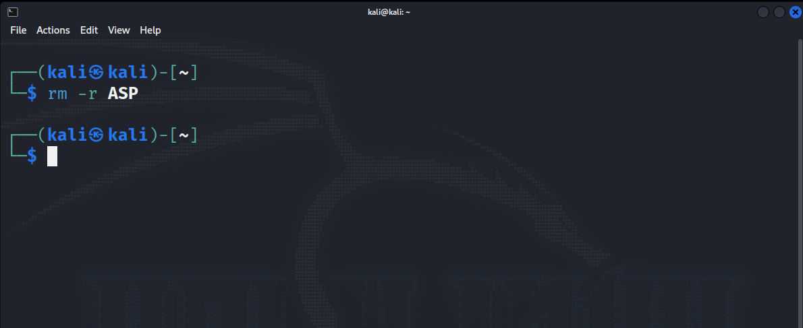

**2) Move to “Web” directory under “ASP” and create the following files.**

**1. Create a "Stud" file which contain 5 student information(id,name,city,dob,mob) seperated field with ",".**

**2. Also Create "Intro" file and write more than 5 line about you.**

**CODE:-**

* cat > Stud

id: 20BCA131, name: Naresh Sharma, city: Surat, dob: 09/12/2000, mob: XXX XXX XX59

* cat > Intro

Hi! My name is Naresh Sharma

I am currently persuing BCA

I am 21 years old

I am currently in last year of my bachelors

I like computers

**Output:**

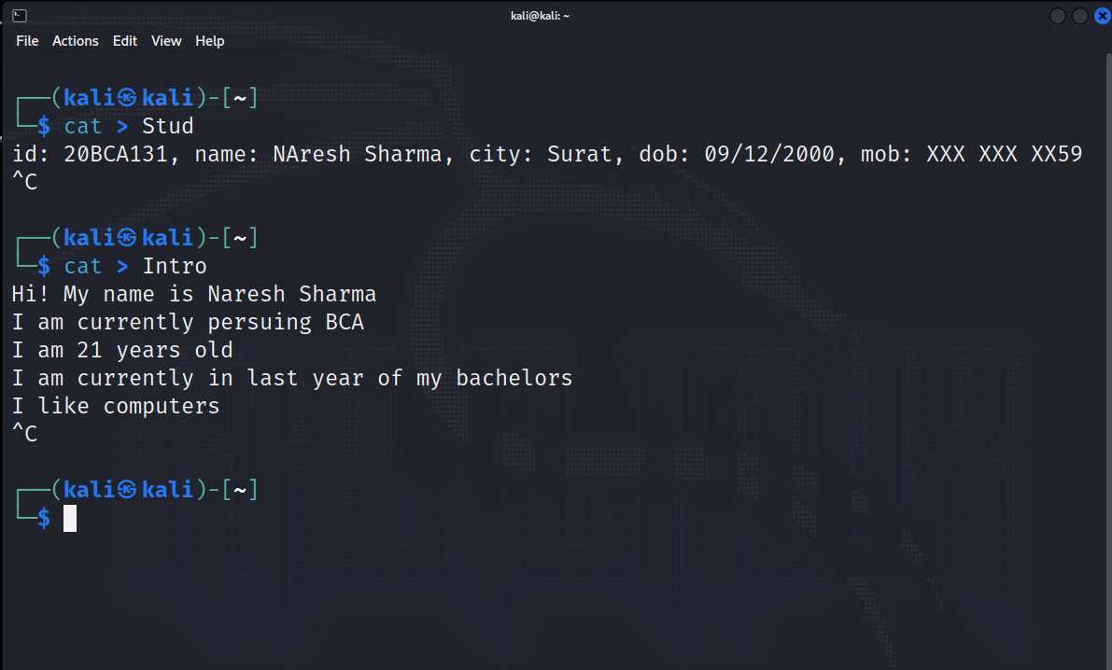

**3) Create another file "Kernel" which contain list of feature of kernel and copy it into "OS" file using cat command.**

**CODE:-**

cat > kernel

1. Ensures the running of programmes is done on time
2. Handles memory allocation
3. Transport data between peripherals

**Output:**

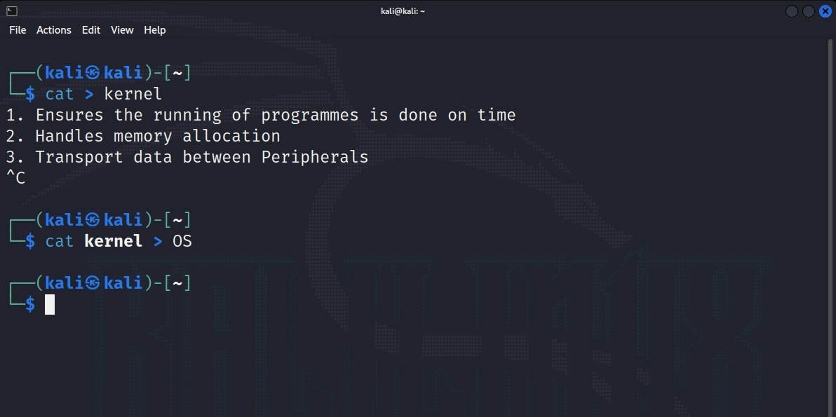

**4) Append data into "Intro" file with more than 10 line about you . Add multiple blank line in file.**

**CODE:-**

cat >> Intro

This is the journal of unix

My current city is Surat

About me line 9

About me line 10

About me line 11

**Output:**

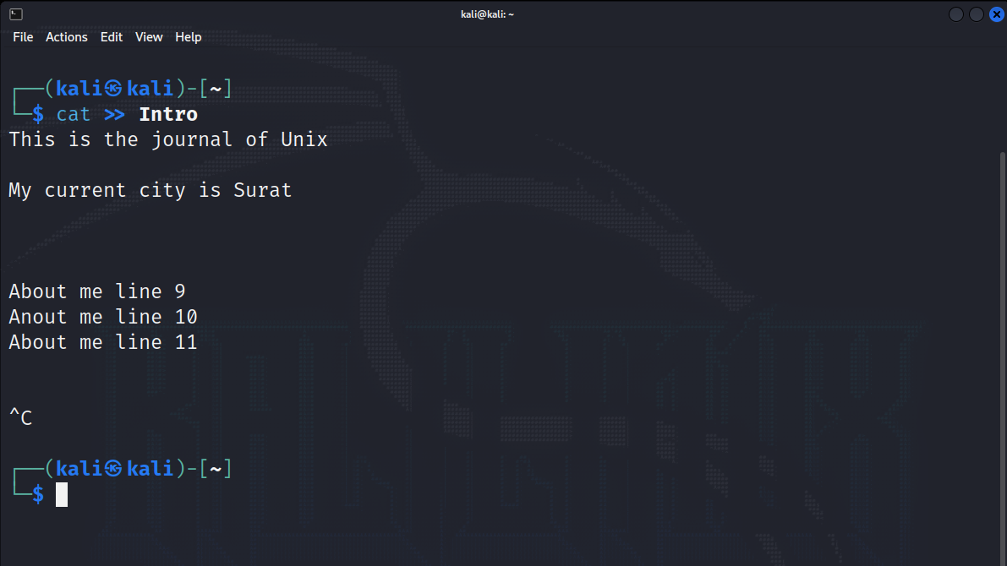

**5) Make a copy of "Stud" file and call it "Stud.bk" and save it under the same directory.**

**CODE:-**

cat stud > stud.bk

**Output:**

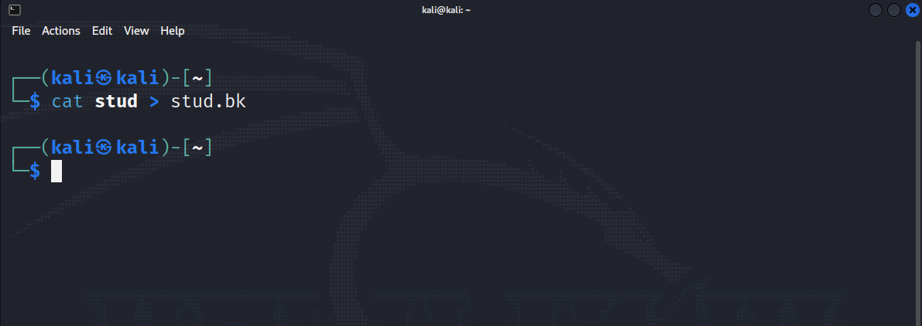

**6) Display both file with visual character and line number.**

**CODE:-**

Mousepad stud stud.bk

**Output:**

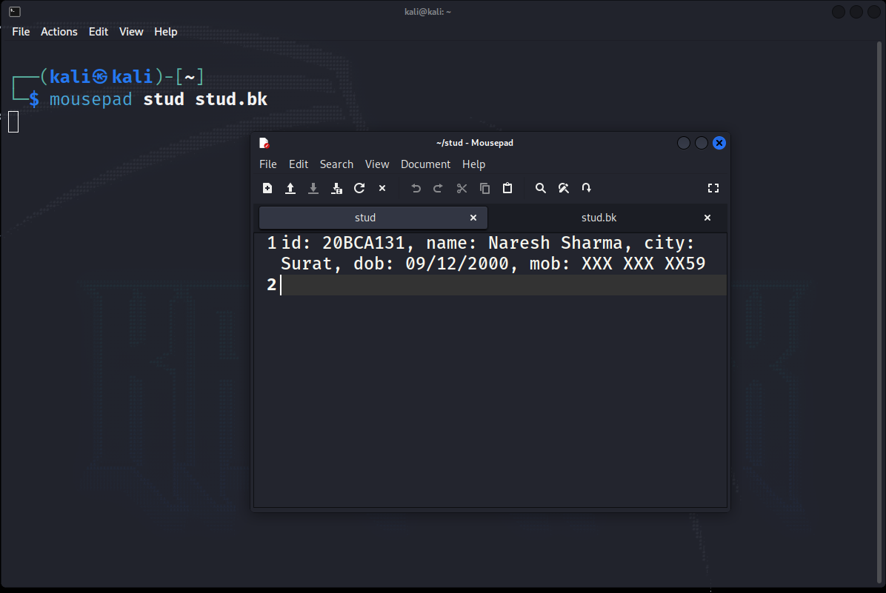

**7) Count the total number of lines in “Stud” file with words and character.**

**CODE:-**

wc Stud

**Output:**

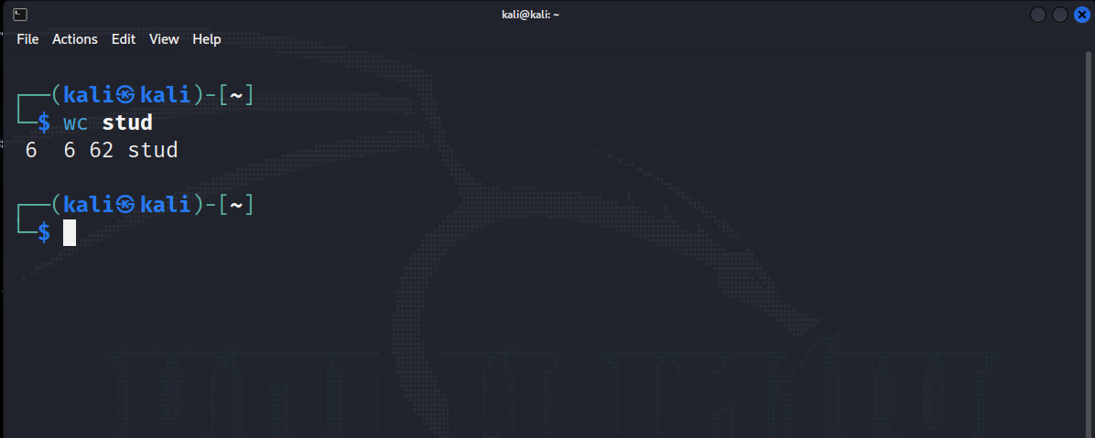

**8) List out all directory created in your drive.**

**CODE:-**

ls –d */

**Output:**

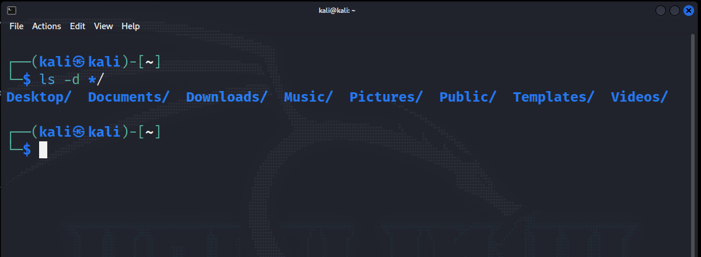

**9) Recursively list all directory in your drive.**

**CODE:-**

ls -R

**Output:**

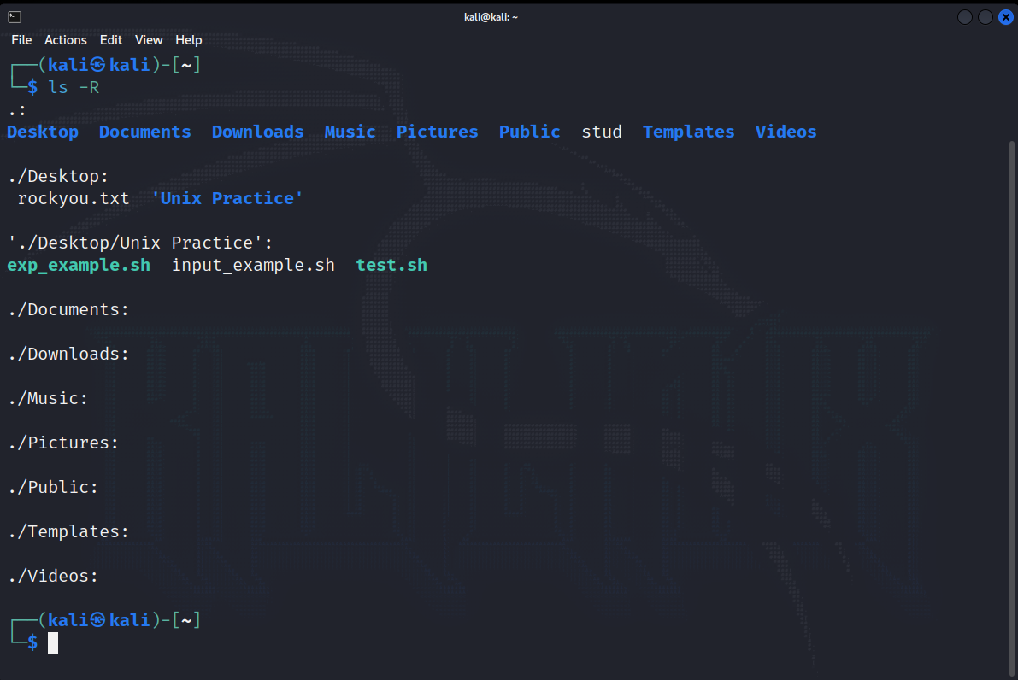

**10) Display long listing details of all files and folders in “Web” directory along with hidden files.**

**CODE:-**

ls -al

**Output:**

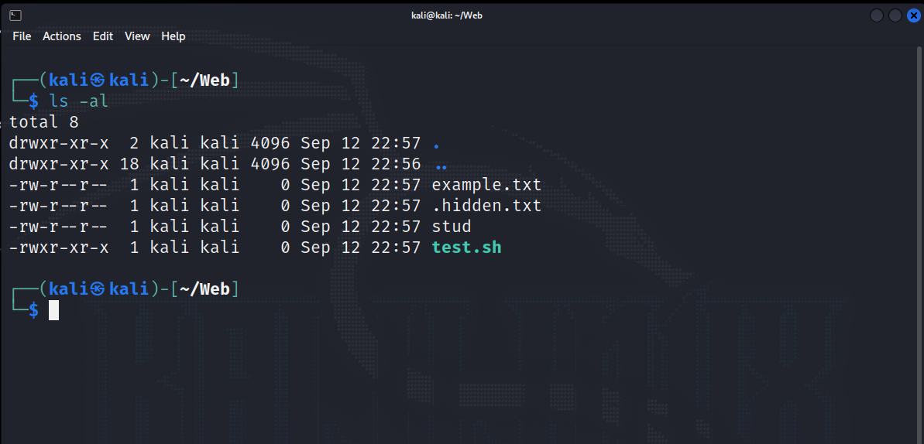

**11) List out all files including hidden files in current directory in reverse order.**

**CODE:-**

ls -ar

**Output:**

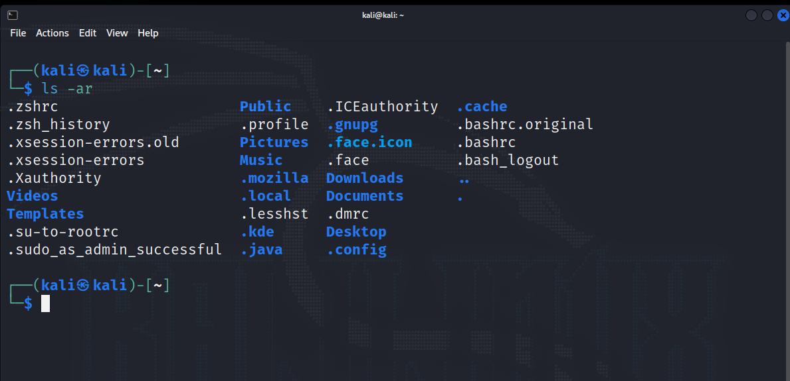

**12) List all files and directory in sorting order as per as its size.**

**CODE:-**

ls -S

**Output:**

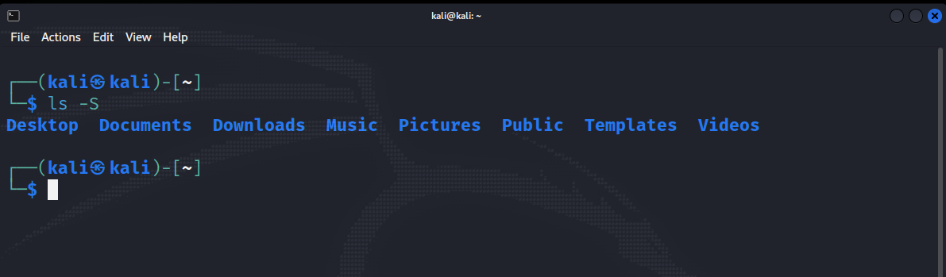

**13) List all file details as per as its modification time.**

**CODE:-**

ls -lt

**Output:**

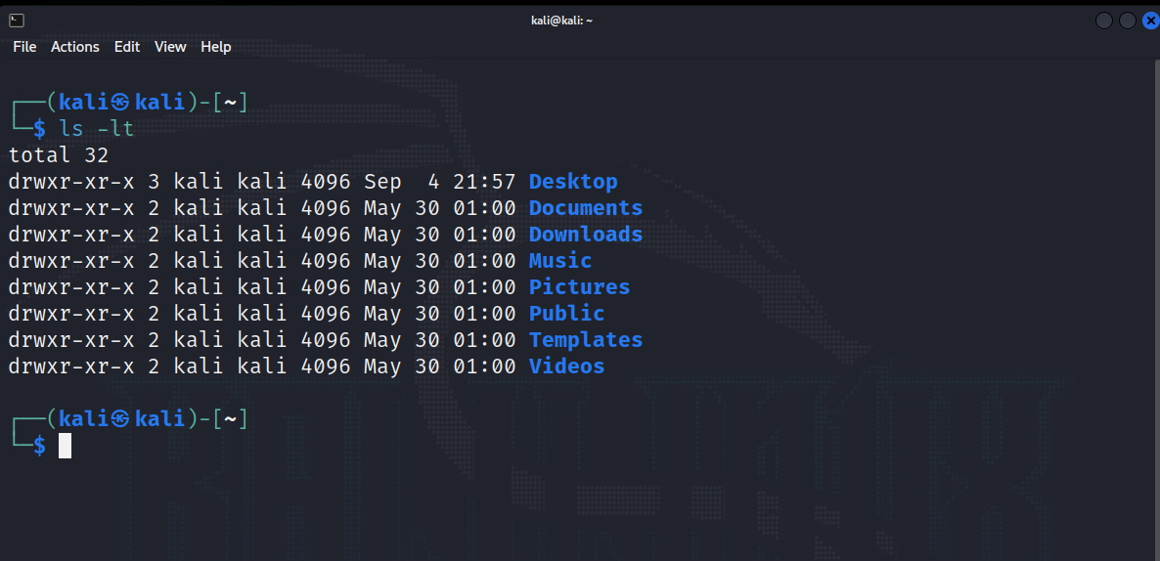

**13) Copy and rename “Stud” and “Intro” file into “Temp” folder of “Exam” in single command.**

**CODE:-**

cp Stud Intro Exam/Temp

**Output:**

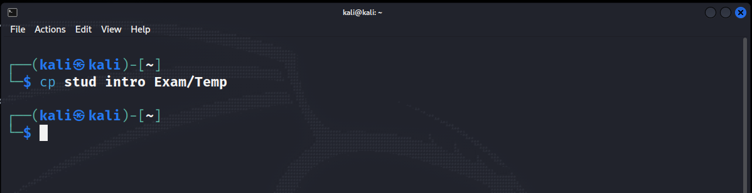

**14) Copy “Intro” file in “Web” folder under “ASP” to the parent directory using dot notation.**

**CODE:-**

cp Intro ../..

**Output:**

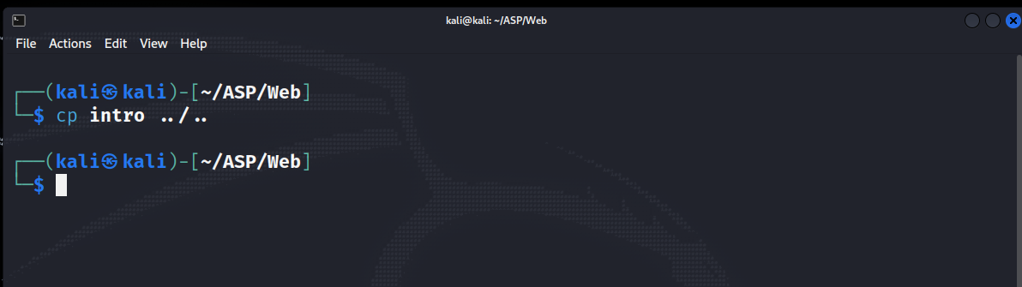

**15) Copy “Exam” folder from “PHP” to “UNIX”.**

**CODE:-**

cp –r Exam ../UNIX

**Output:**

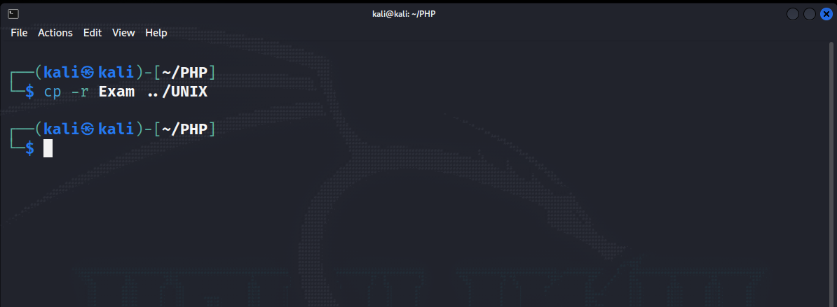

**16) Recursively copy entire “Web” folder into “PHP”.**

**CODE:-**

cp –r Web PHP

**Output:**

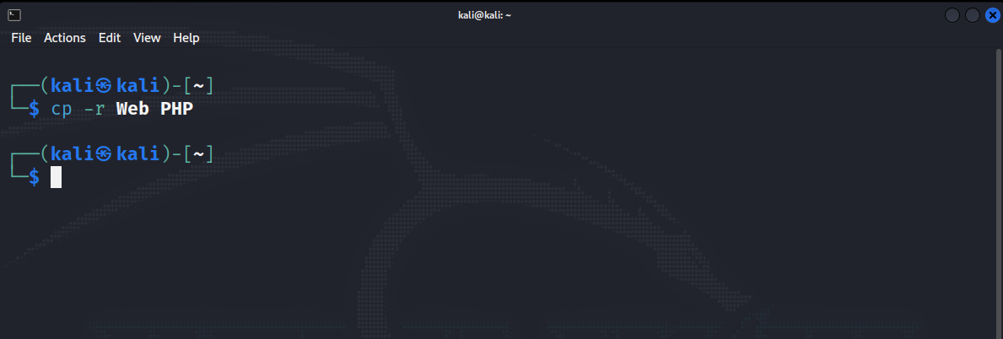

**17) Rename “Stud” file with “Student”.**

**CODE:-**

mv Stud Student

**Output:**

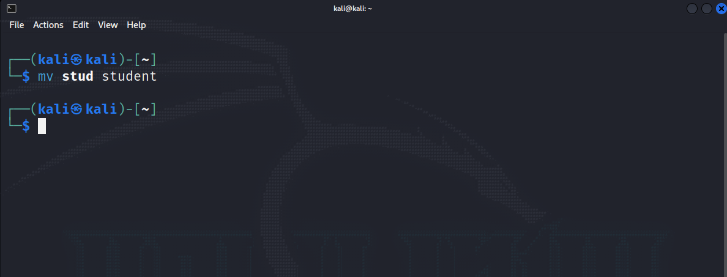

**18) Remove “Student.bk” file.**

**CODE:-**

rm Stud.bk

**Output:**

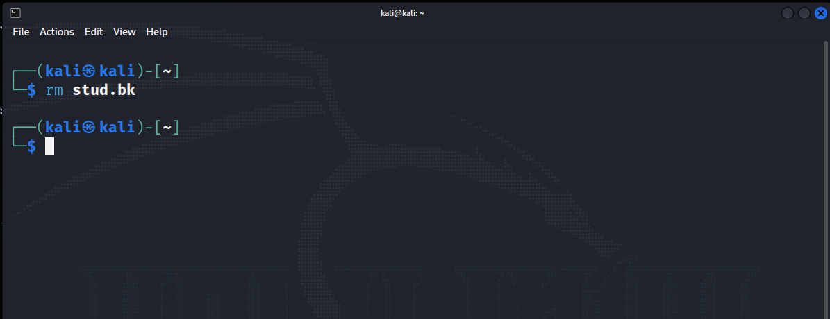

**19) Remove “Temp” folder with all its subdirectories and files.**

**CODE:-**

rm –r Temp

**Output:**

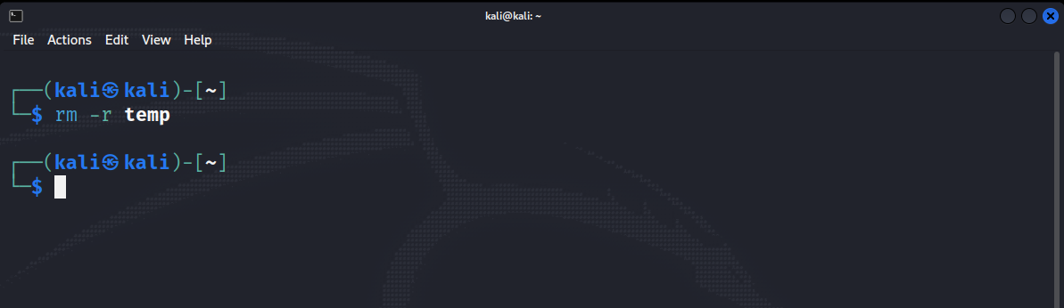

**20) Create empty files temp1, temp2 and temp* in UNIX directory. Delete only the “temp*” file.**

**CODE:-**

rm ‘temp*’

**Output:**

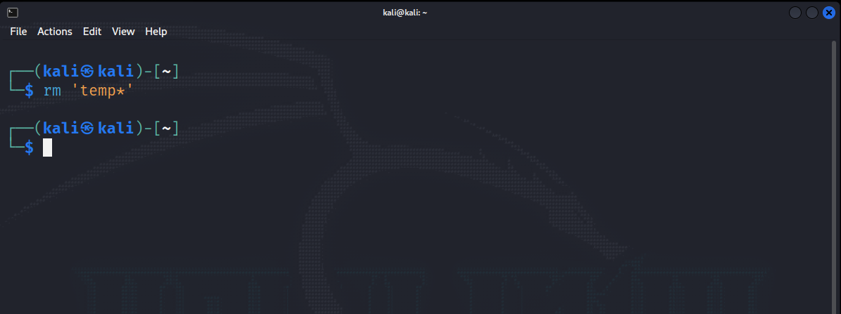

**21) Forcefully delete all files from PHP directory.**

**CODE:-**

rm –rf PHP

**Output:**

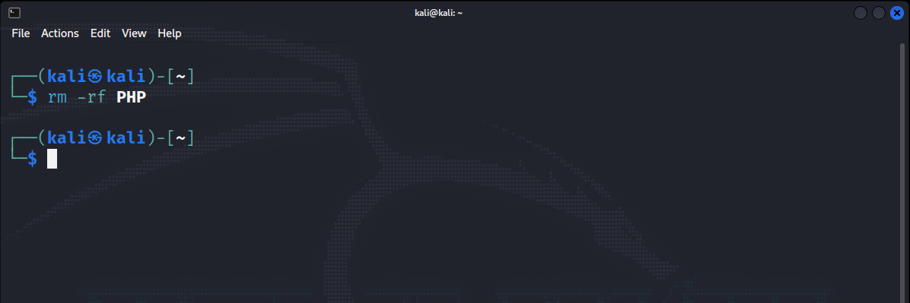

**22) Move “Student” file into “UNIX”.**

**CODE:-**

mv Student UNIX/

**Output:**

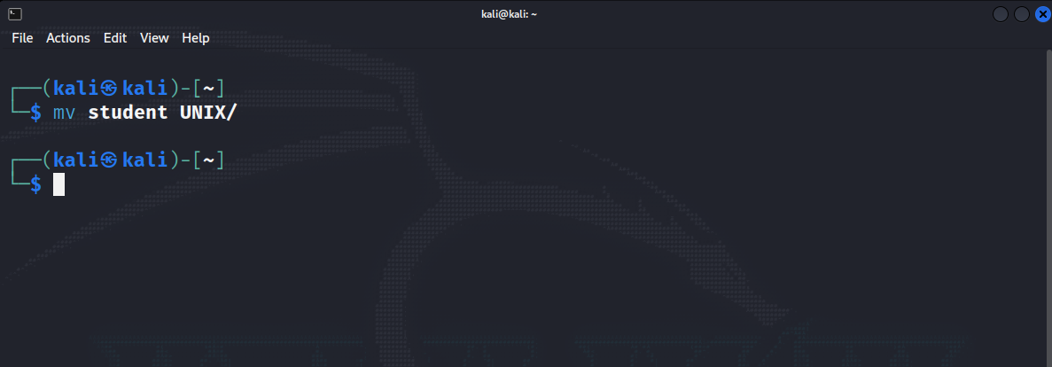

**23) To find file having a .txt extention.**

**CODE:-**

find *.txt

**Output:**

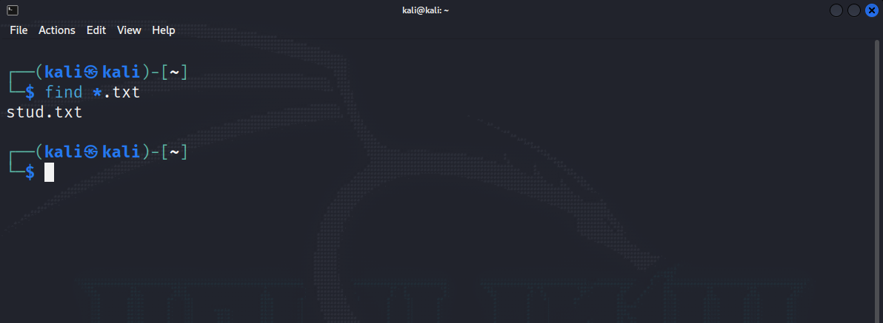

**24) To find file having size greater than 5.**

**CODE:-**

Mousepad stud stud.bk

**Output:**

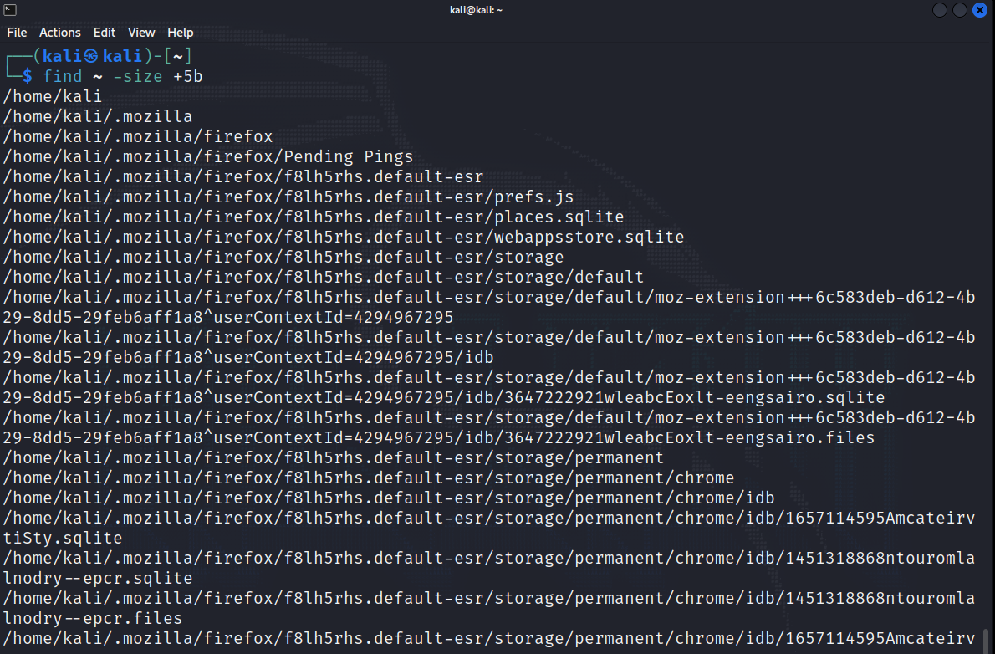

**LAB 3**

**1) "Create two files under ""UNIX"" directory name ""BCA"" and ""BBA"" withduplicate records( student id,name, city, Pincode, Sem, DOB).**

**Enter city ""Bardoli"" In more than 3 records.**

**Enter duplicate records also.**

**Date should be in dd/mm/yyyy format. Not Enter heading in file. See Below example.**

**( Example : 1 | OM | BARDOLI | 394601 | 5 | 11/08/1992 )".**

**CODE:-**

cat > bca.txt

cat > bba.txt

**Output:**

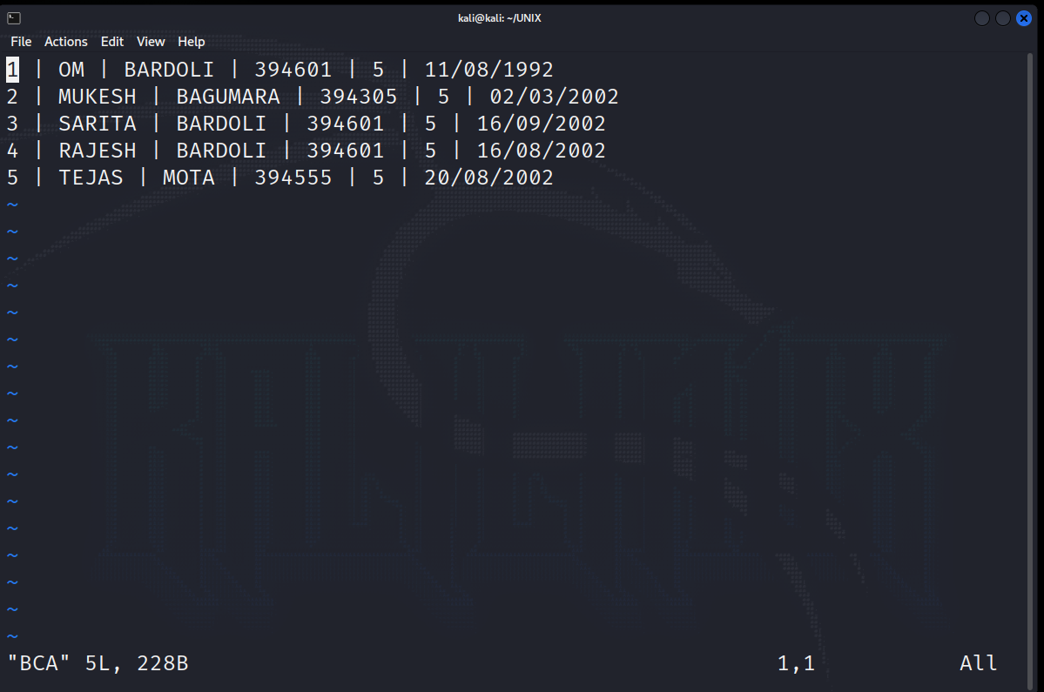

**2) Write command to display first five lines from file "Intro" under "Web" Directory.**

**CODE:-**

**Output:**

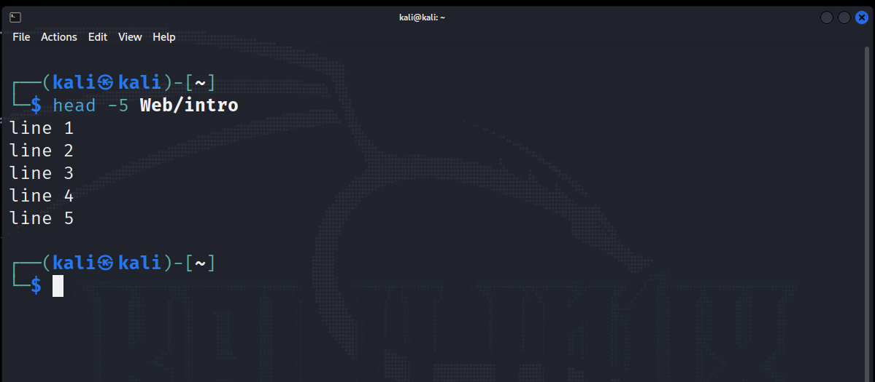

**3) Display first 5 character of file "intro".**

**CODE:-**

head –c 5 intro

**Output:**

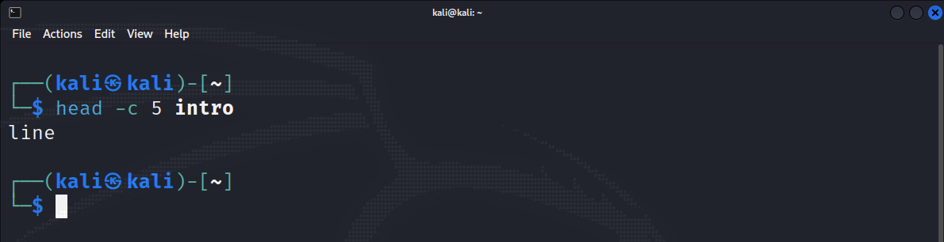

**4) Count number of character from first five lines of file "Intro".**

**CODE:-**

Head –n5 intro | wc -c

**Output:**

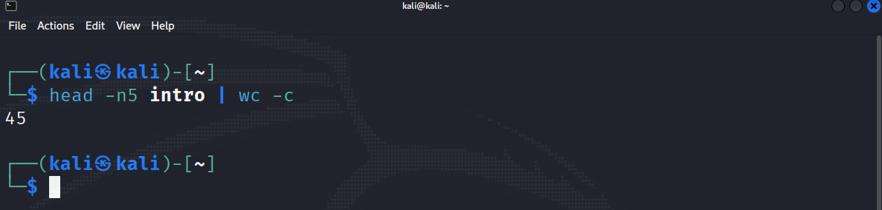

**5) List 3 most recently used file in PWD.**

**CODE:-**

ls -lt

**Output:**

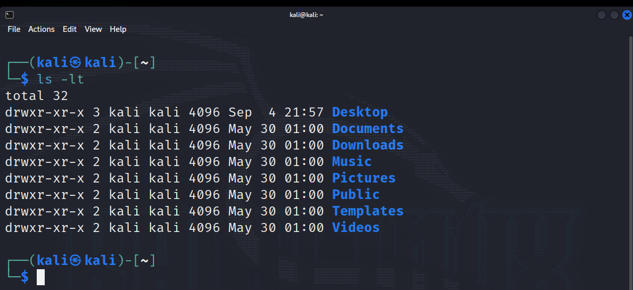

**6) Display last five lines from file "Intro" under "Web" Directory.**

**CODE:-**

tail –n5 intro

**Output:**

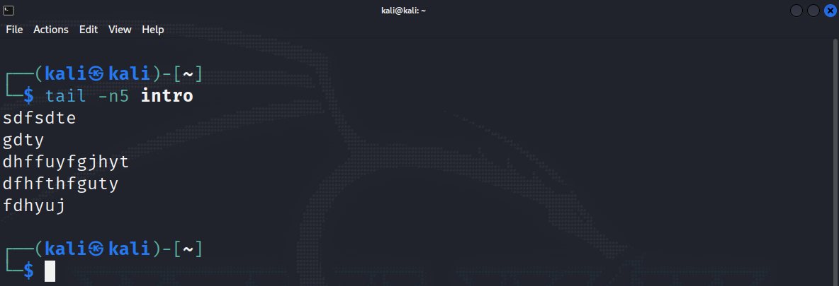

**7) Count number of character in last line of "intro" file.**

**CODE:-**

tail intro | wc -c

**Output:**

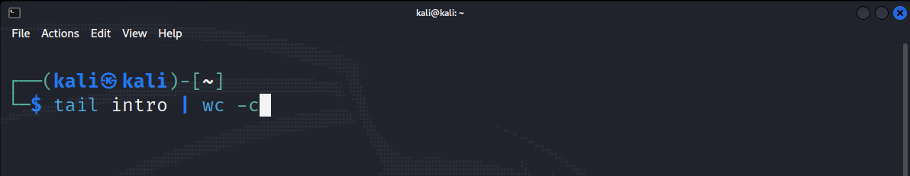

**8) Display lines 4 to 9 from file "Intro".**

**CODE:-**

head -9 intro | tail +4

**Output:**

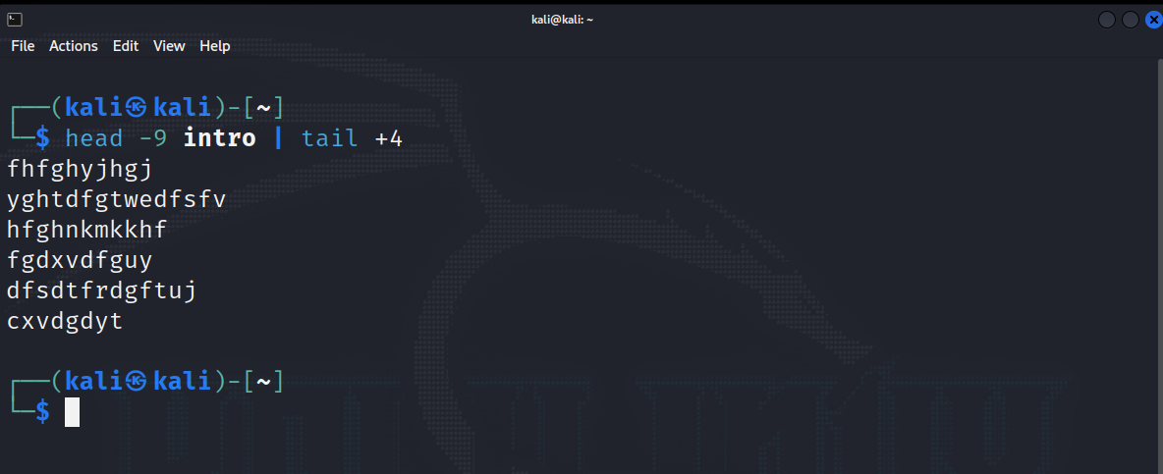

**9) Display two lines starting from 7th line of file "intro".**

**CODE:-**

head –n8 intro | tail -2

**Output:**

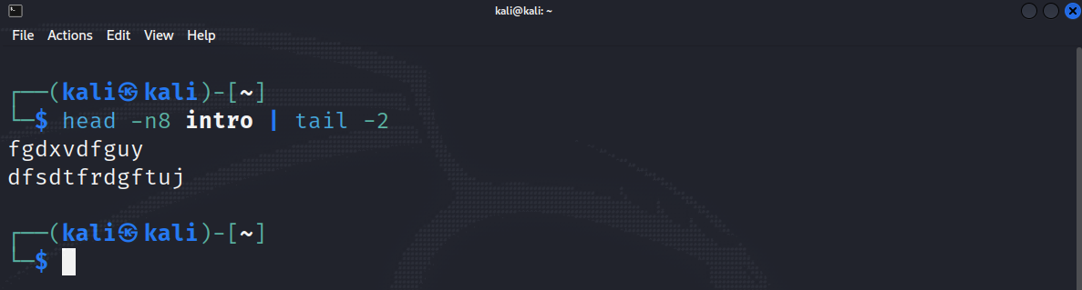

**10) Count number of words in line 8 to 12 in file "intro".**

**CODE:-**

head –n12 intro | tail -5 | wc -c

**Output:**

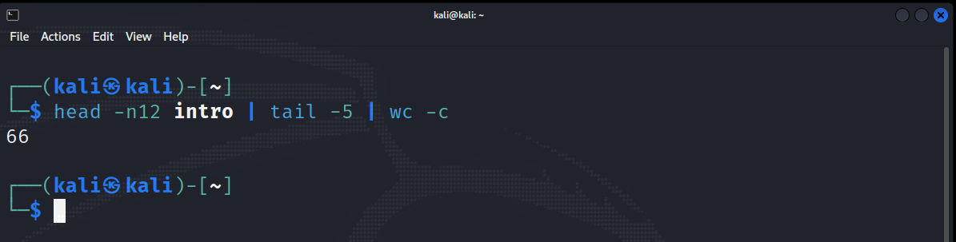

**11) Display last five character of file "intro".**

**CODE:-**

tail –c5 intro

**Output:**

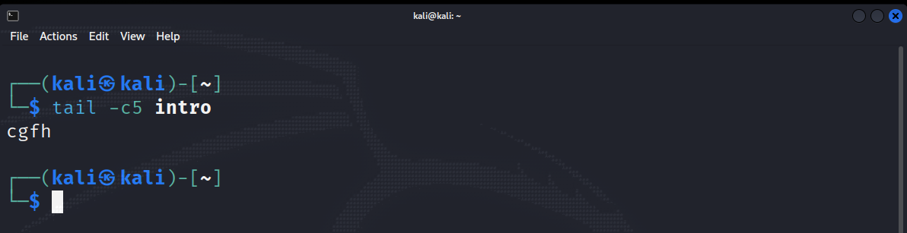

**12) Display characters from 2oth byte of "Intro".**

**CODE:-**

tail –c+20 intro && tail -c20 intro

**Output:**

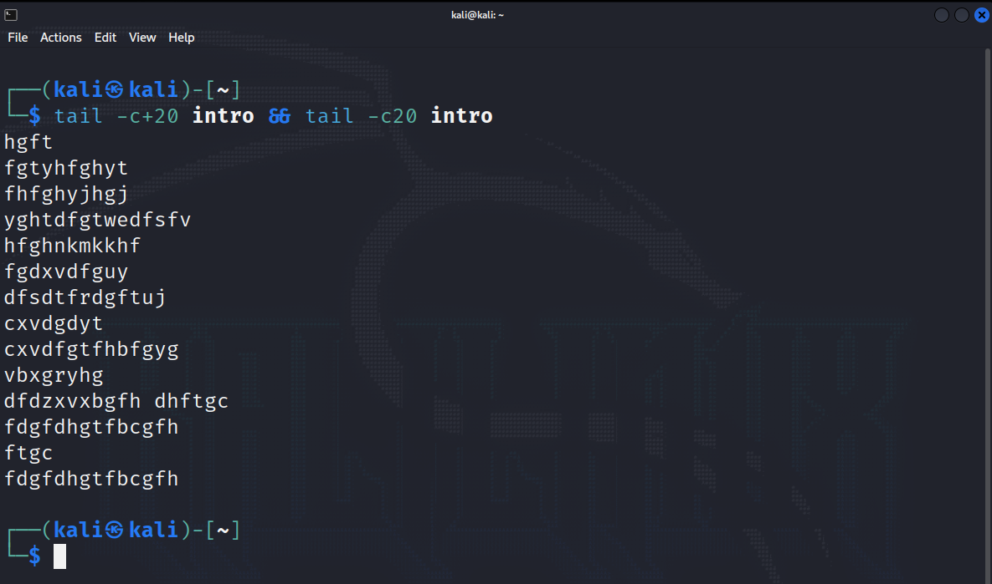

**13) Display only 1st character of each lines.**

**CODE:-**

cut –c 1 intro

**Output:**

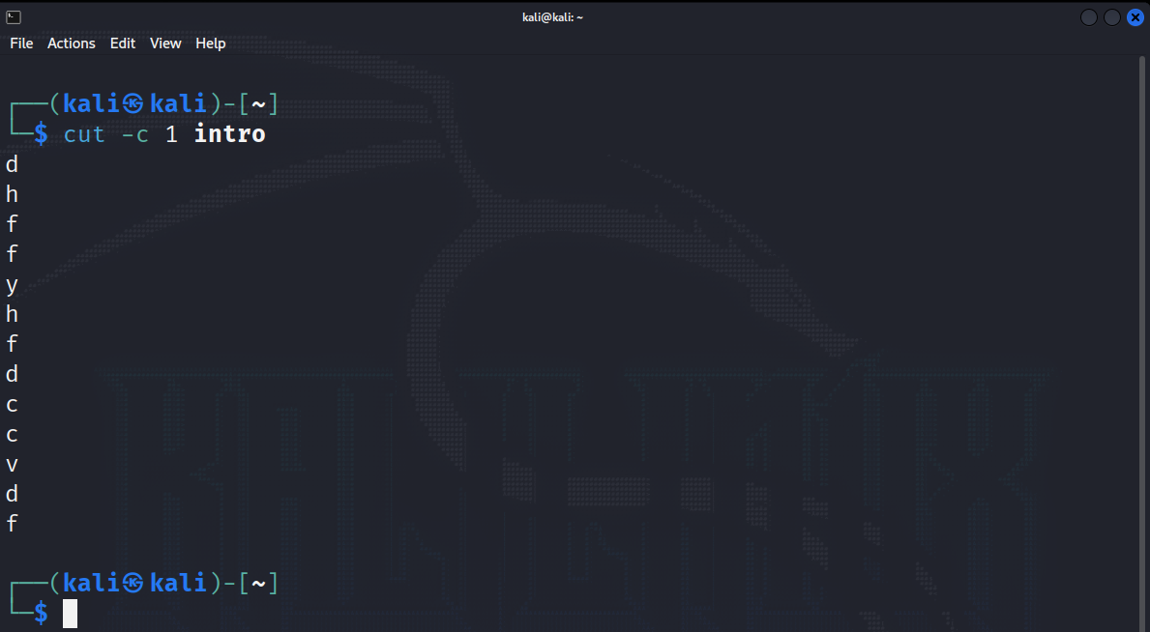

**14) Display only 5 to 8 character of each lines.**

**CODE:-**

cut –c 5,6,7,8 intro

**Output:**

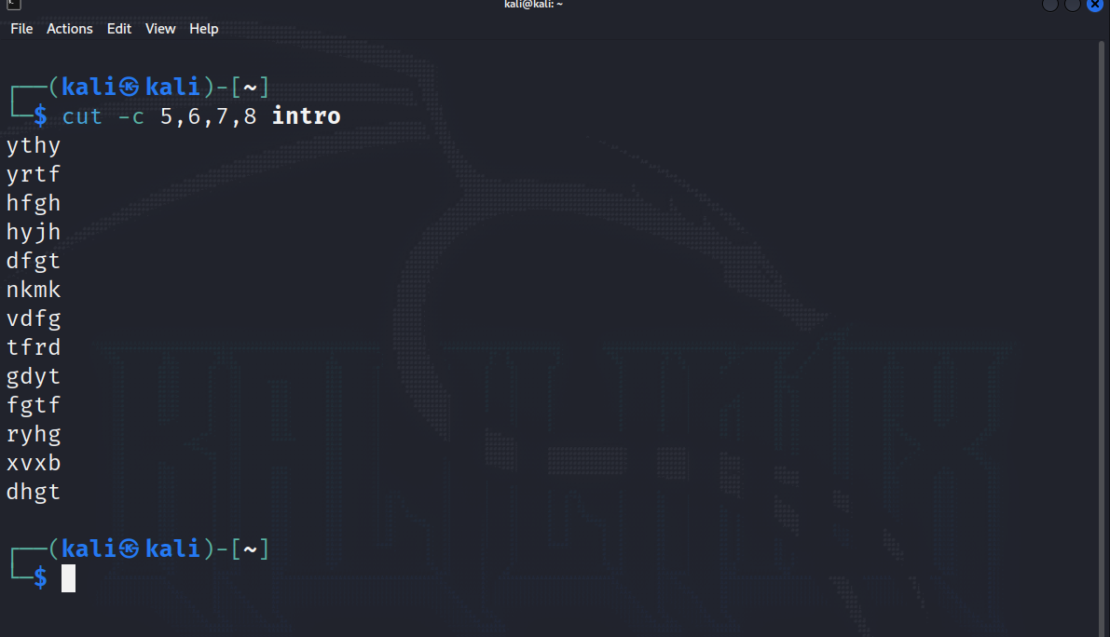

**15) Display first 5 character of each lines.**

**CODE:-**

cut –c 5 intro

**Output:**

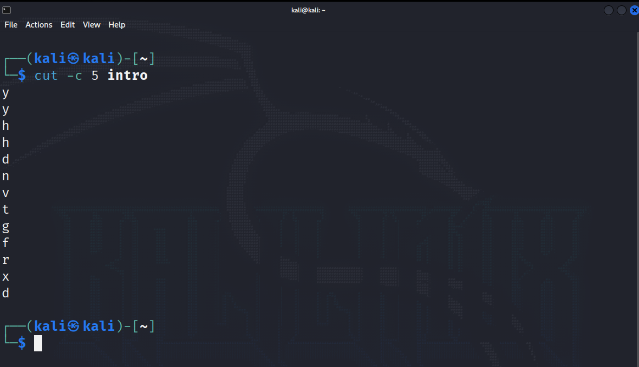

**16) Display only 2nd field from "Stud" file of "Web".**

**CODE:-**

cut –d “,” –f2 stud.bk

**Output:**

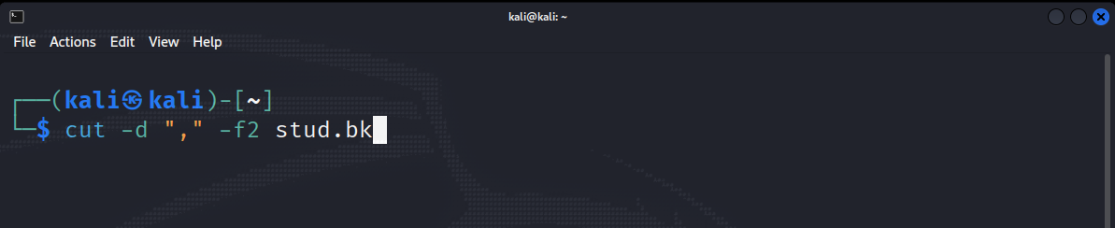

**17) Display only 2nd to 3rd field from "Stud" file of "Web".**

**CODE:-**

cut –d “,” –f2,3 stud.bk

**Output:**

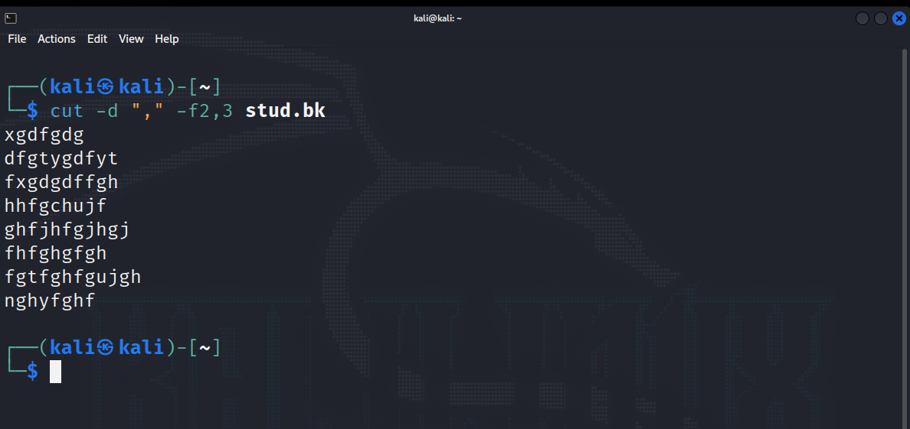

**18) Display only 2,3, and 5 field form "Stud" file.**

**CODE:-**

cut –d “,” –f2,3,5 stud.bk

**Output:**

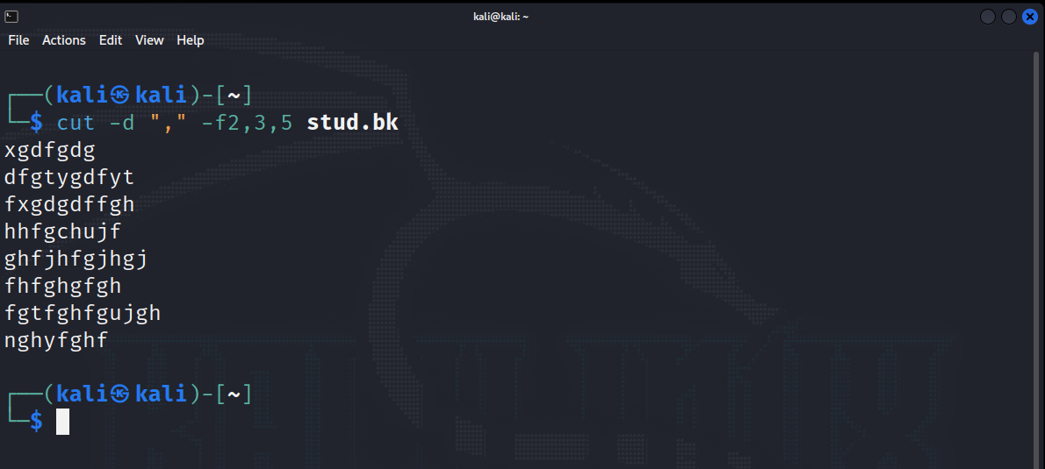

**19) To Print field 2 to 5 from "stud" file.**

**CODE:-**

cut –d “,” –f2-5 stud.bk

**Output:**

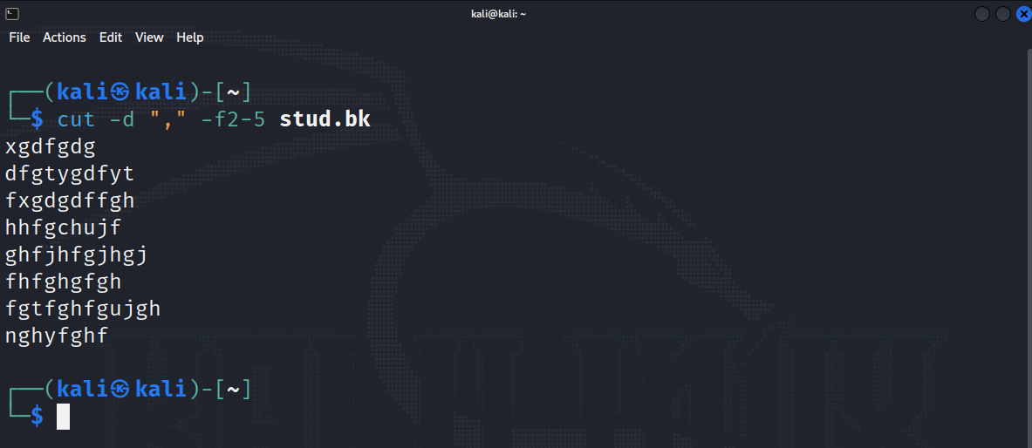

**20) Merging two file "BCA" and "BBA" with delimiter ":".**

**CODE:-**

paste –d ‘:’ bba.txt bca.txt

**Output:**

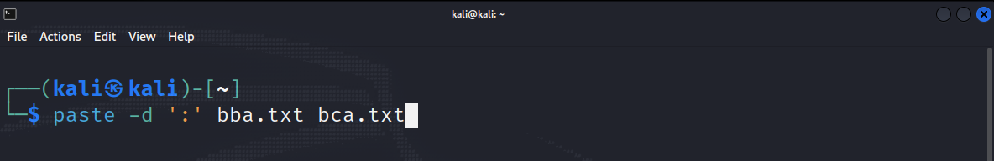

**21) Sort File "BCA" .**

**CODE:-**

sort bca.txt

**Output:**

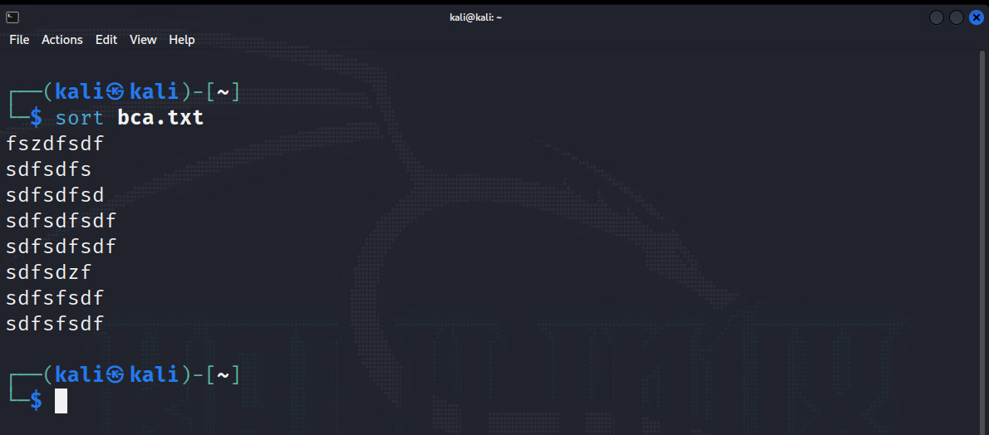

**22) Sort File "BBA" and display only unique records. Use delimiter "|"**

**CODE:-**

sort bba.txt | uniq

**Output:**

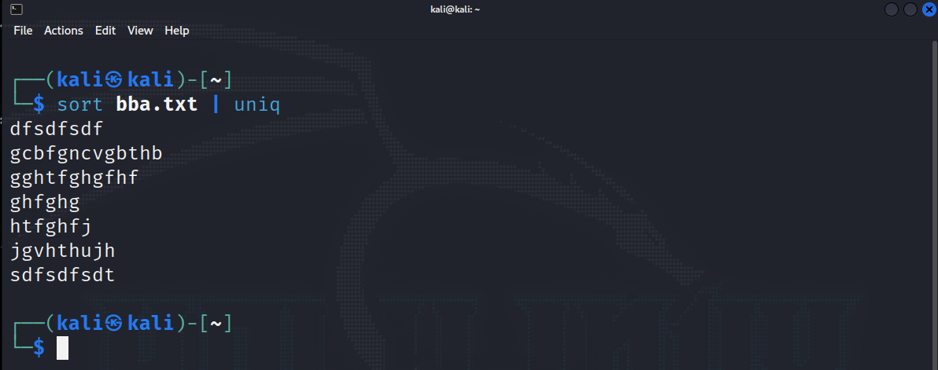

**23) Sort File "BCA" on "ID" field.**

**CODE:-**

sort –k1,1 bca.txt

**Output:**

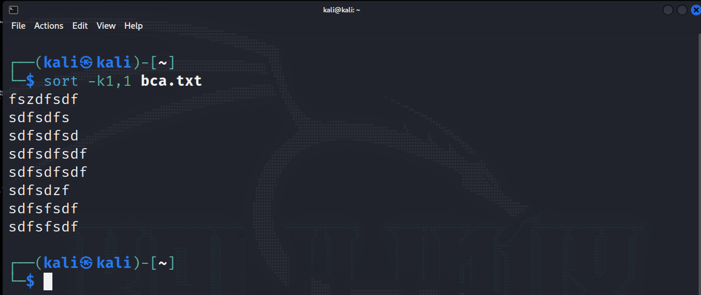

**24) Sort file "BBA" on "Pincode" which is a numeric field in decending order.**

**CODE:-**

sort –r –k4n,4 bba.txt

**Output:**

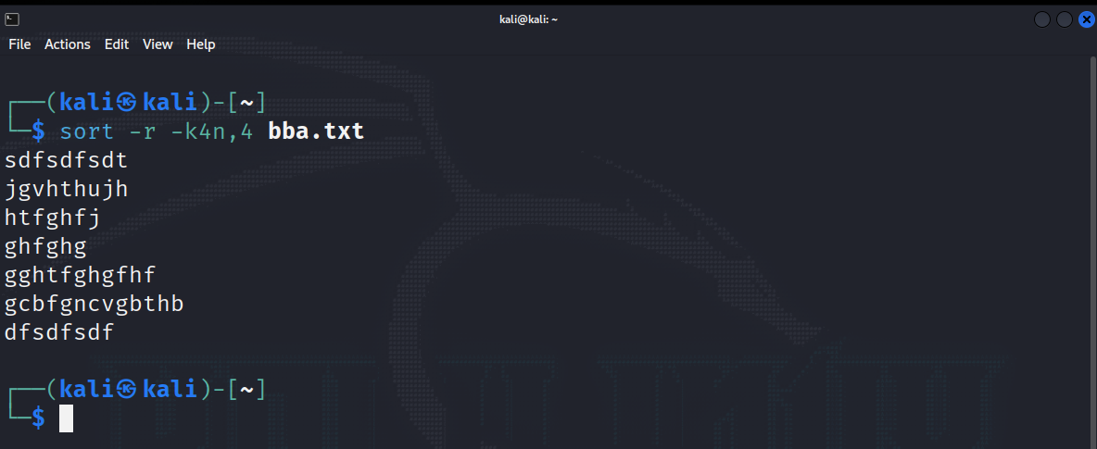

**25) Sort file "BCA" on multiple field "ID" and "City" use delimiter ","**

**CODE:-**

sort –t ‘|’ –k1n,3 bca.txt

**Output:**

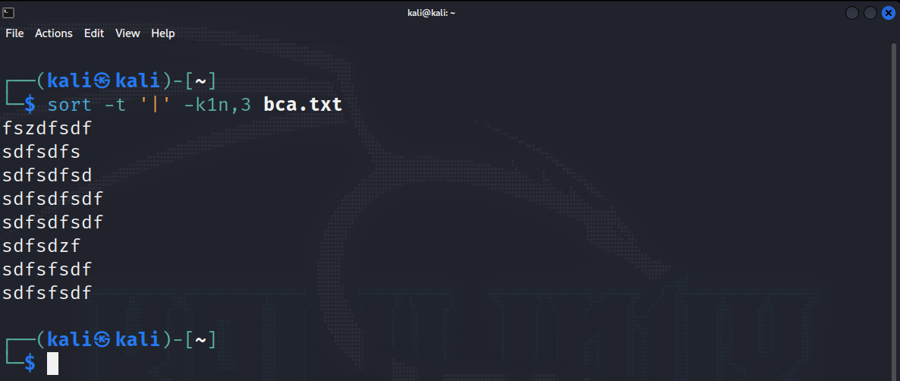

**26) Sort file "BBA" on "Year of Birth" in ascending order with delimiter ":"**

**CODE:-**

sort –k 6.9,9.10 bba.txt | tr ‘|’ ‘:’

**Output:**

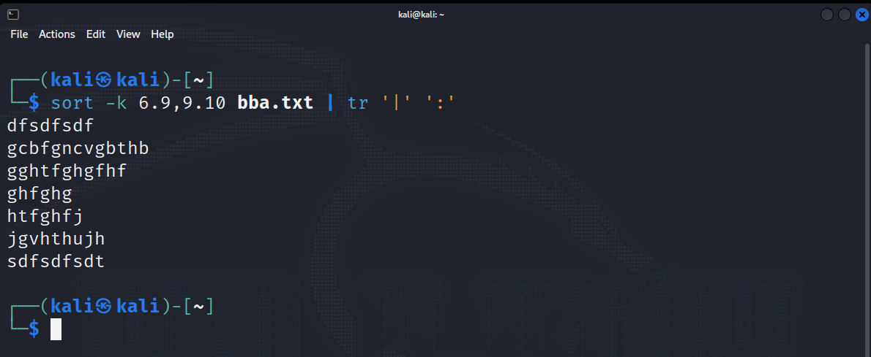

**27) Sort file by last access time.**

**CODE:-**

ls –l | sort –k8 –k8.4,8.5n

**Output:**

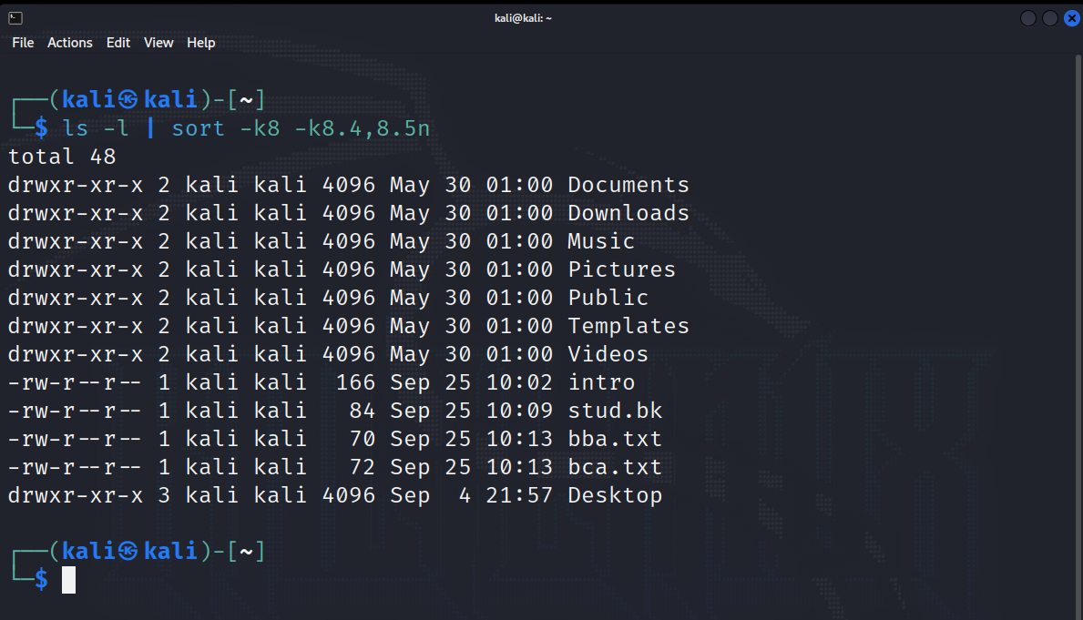

**28) Display number of unique line in file "BCA".**

**CODE:-**

uniq –c bca.txt

**Output:**

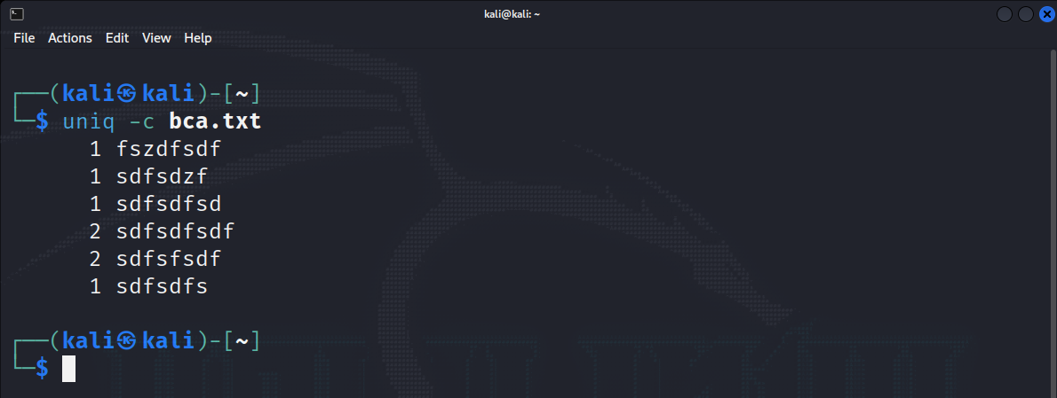

**29) Display unique line from file "BCA".**

**CODE:-**

uniq bca.txt

**Output:**

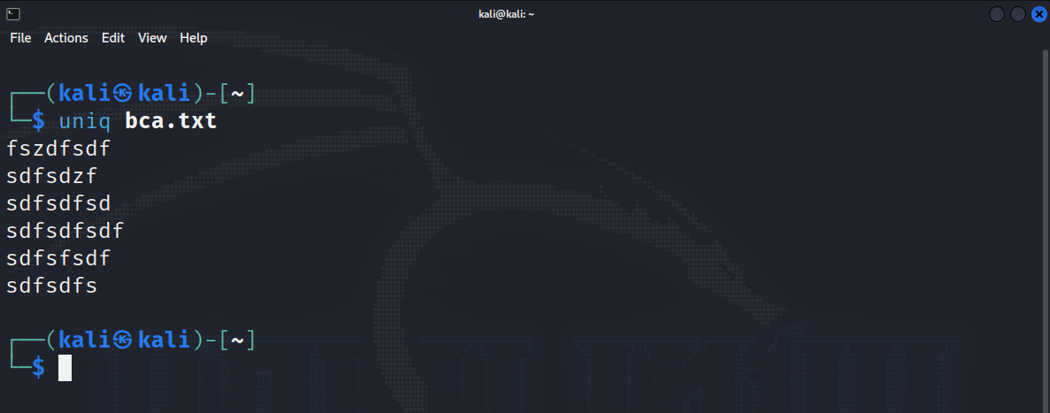

**30) To remove duplicate line from a file "BBA".**

**CODE:-**

uniq –u bba.txt

**Output:**

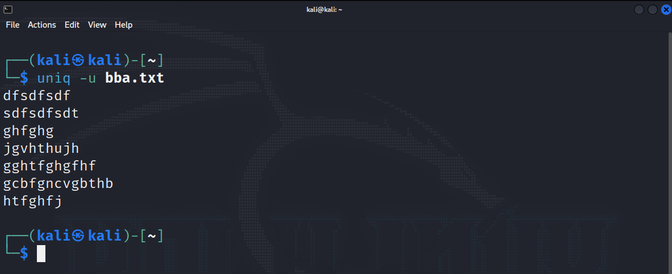

**31) Display only duplicate line in file "BBA".**

**CODE:-**

uniq –d bba.txt

**Output:**

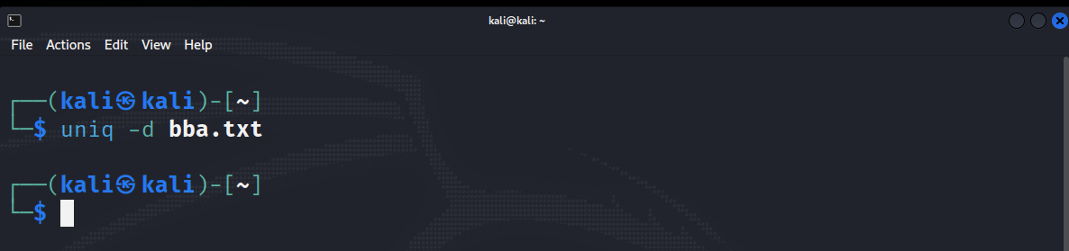

**32) Print frequency of each line from file "BCA"**

**CODE:-**

cat bca.txt | tr –s ‘ ‘ ‘\n’ | sort | uniq –c | awk ‘{print$2,$1}’

**Output:**

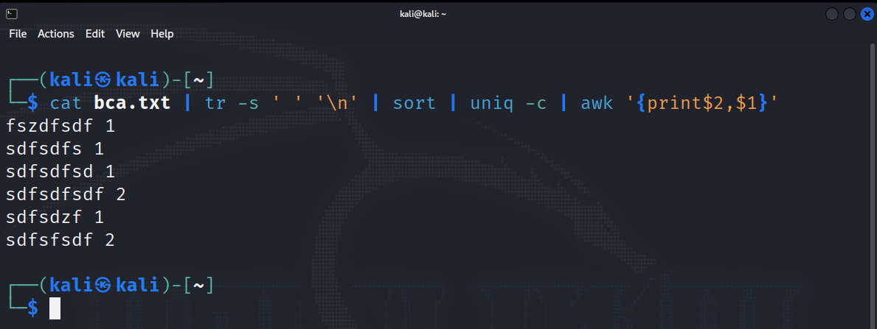

**33) Move to "Web" Directory**

**CODE:-**

cd asp && cd web

**Output:**

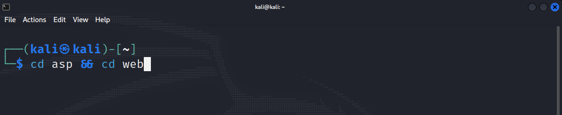

**34) Translate "Intro" file into "Upper case".**

**CODE:-**

tr [a-z] [A-Z] < intro

**Output:**

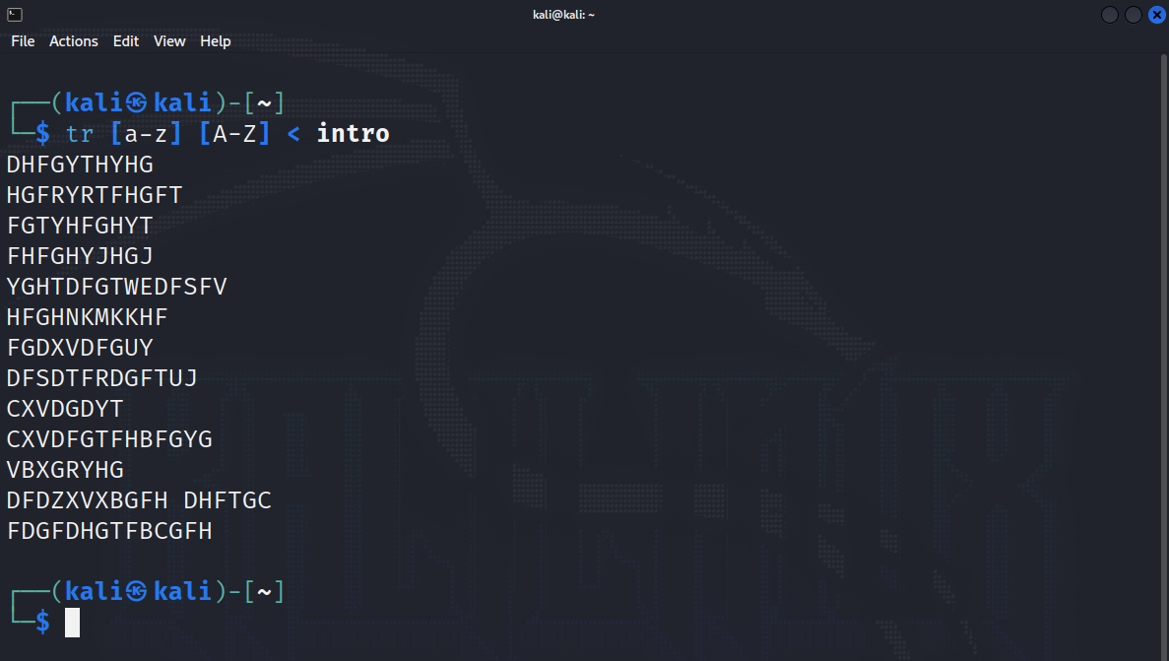

**35) Translate "Stud" file with delimiter "-" and print only 3 records.**

**CODE:-**

cat stud | tr ‘,-‘ ‘-‘ | head -3

**Output:**

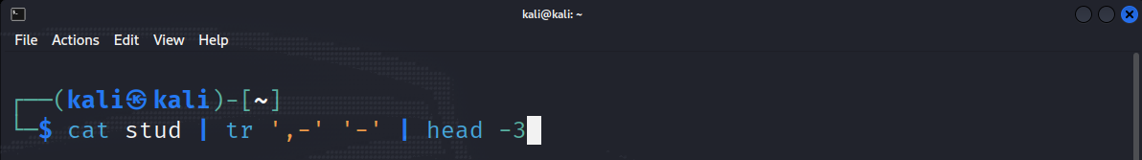

**36) Delete vowel from "Intro" files.**

**CODE:-**

tr –d [a,e,i,o,u] < intro

**Output:**

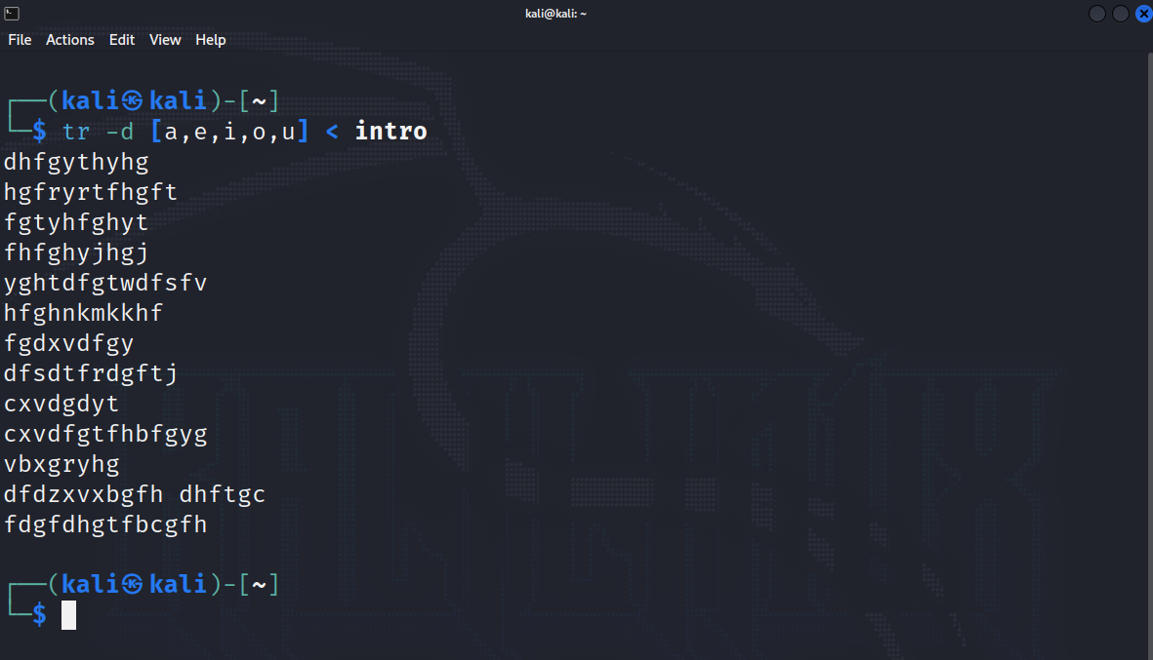

**37) Remove all leading spaces from file "Into".**

**CODE:-**

tr –s “ “ < intro

**Output:**

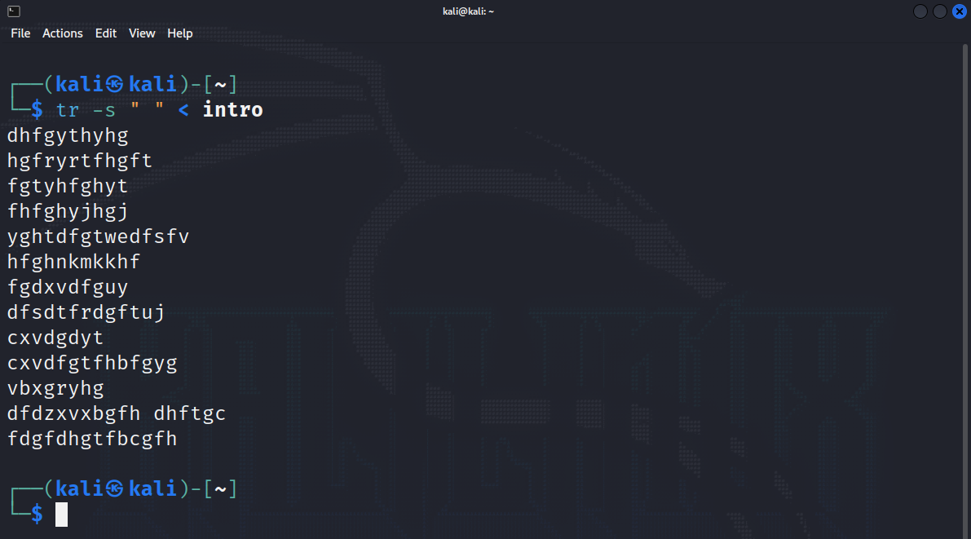

**38) To delete all special character in "BCA" file.**

**CODE:-**

cat bca.txt | tr –d ‘||’

**Output:**

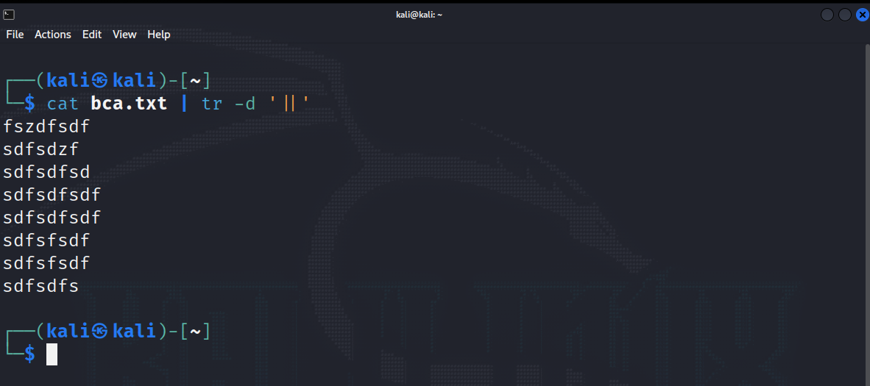

**39) Replace multiple space between two words with single space.**

**CODE:-**

cat intro | tr –s “ “

**Output:**

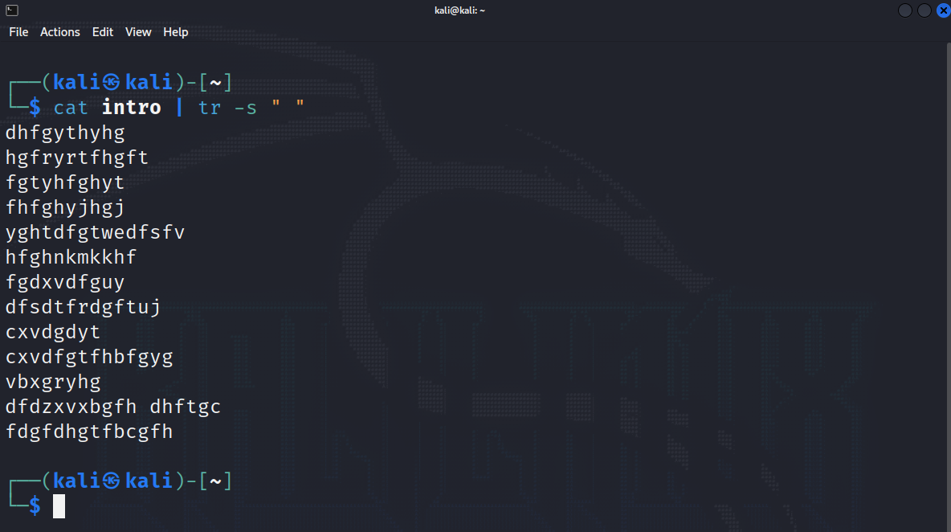

**40) Write a command to sort a line of "BCA" file and remove repeated lines.**

**CODE:-**

cat bca.txt | uniq

**Output:**

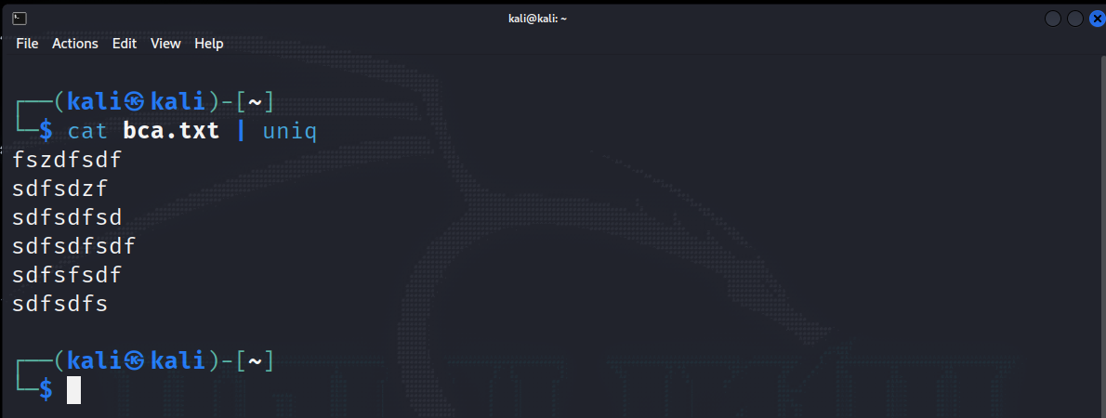

**41) Replace all occurance of "Bardoli" with "Baroda" in"BBA".**

**CODE:-**

tr “Bardoli” “Baroda” < bba.txt

**Output:**

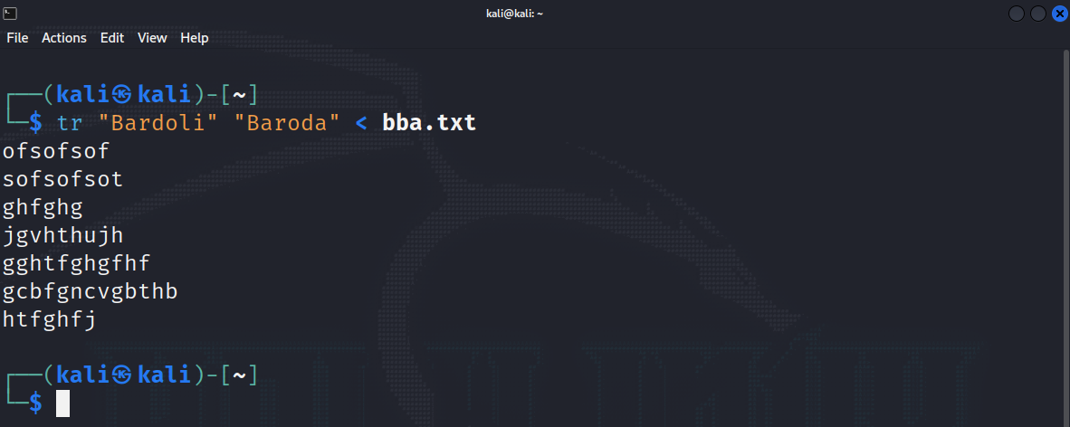

**42) Replace all occurance of "Bardoli" with "Baroda" in 5th line of "BCA"**

**CODE:-**

head -5 bca.txt | tail +5 | tr “Bardoli” “Baroda”

**Output:**

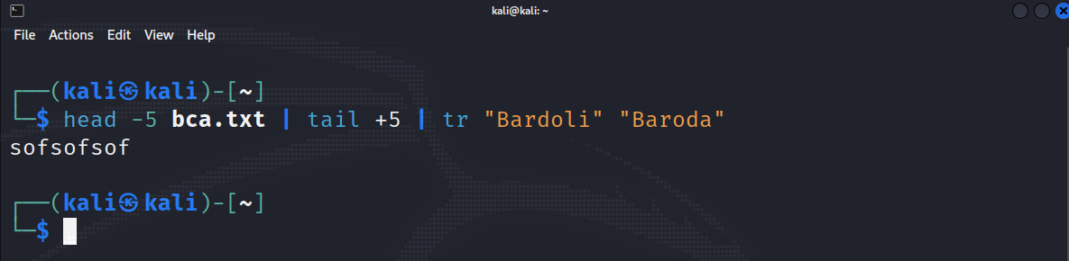

**43) Count all occurance of "My" in "Intro" file**

**CODE:-**

cut –f 1 intro | grep –I “My” | wc -l

**Output:**

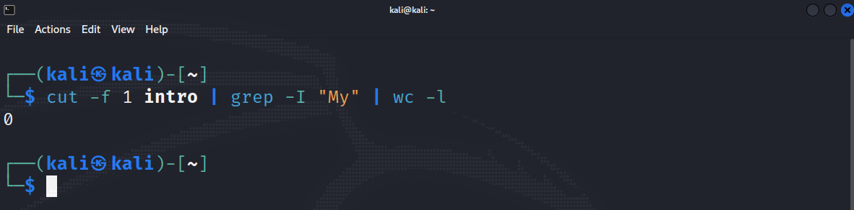

**44) To Count the number of words in line 5 to line 10 of file "Intro".**

**CODE:-**

head -10 intro | tail +5 | wc -c

**Output:**

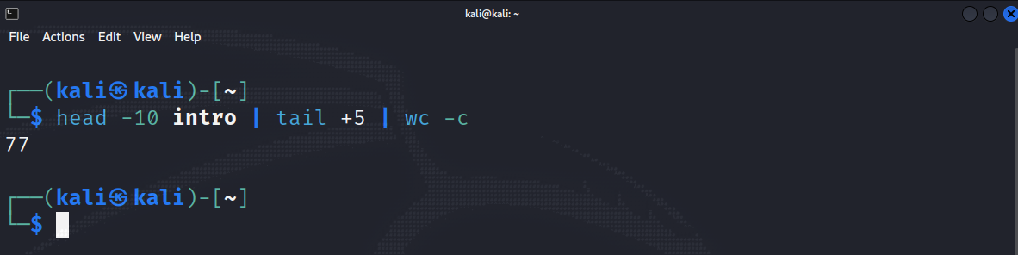

**45) To move all files begin with digit from parent directory to the current directory.**

**CODE:-**

find | grep “^[1-9]” | cd

**Output:**

